HSS 102
April 15, 2016

Landmark Experiments I: Torricelli and Harvey
Torricelli invents the barometer
Around 1630s, hydraulics became an important issue of scientific debate in Italy. [historical background: Archiemedes water screw; followed by suction pumps. Suction pumps were in use for a long time. See the ppt for the suction pumps used for draining mines in the 15th c).
The problem this: Italian architects and engineers wanted to raise water for buildings and fountains and they discovered that they simply could not raise it beyond a height of 10 meters or 33 feet. Pumps could not draw water more than this height and siphons failed to operate in hills higher than this height.
This was a big engineering problem as engineers and architects wanted to lift water to supply to buildings that were higher than 10 meters and for use in fountains and such. Italian engineers even approached Galileo with the problem, but he could merely confirm the fact, and not provide a clear answer. Galileo thought that the explanation lay in vaccum: unlike the arisotelians G. believed that vacuum could exist and it is vacuum that held up the column of water at a certain height. After that height the amount of water became too much and the force of vacuum could not hold it any more, like a rope that can only withstand so much weight hanging from it.
In Rome, an amateur scientist named Gasparo Berti set up a series of experiments to study this curious phenomenon in detail. He used a long tube, plugged from both ends, filled completely with water and placing the tube vertically in a basin already filled with water, brought the tube in a vertical position and opened the bottom end.: ome of the water poured in the tub, but not all, leaving a vertical column of water with a height of about 10 metres in the pipe - this was, obviously, exactly the limiting height of the pumps that had puzzled the engineers.
The question then became: what was in the space above the water level in the tube. The water inside the tube was not in contact with air outside, so it could not be air. Then what was in that space? This suggested the possibility of vacuum.
Many explanations were offered: the Aristotelians denied that vacuum could exist and believed that if it did, sound and light could not pass through it. Both sound and light did pass through the space above the column and therefore Aristotelians denied that it could be vacuum. So what was it if not void? The subtle ether was one candidate.
The whole issue was very confusing. Until Torerricelli stepped in and looked at it from a fresh perspective which he derived from Archimedes and his own guru, Galileo.

In 1644, one of Galileo’s admirers and followers –Evangelista Torricelli (1608-47) – applied Galileo’s thinking of air as a fluid which has weight and buoyancy (just as any fluid) to the problem of the pump. In the process he ended up inventing the barometer. You acknowledge his contribution when you use “torr” as a unit of pressure.
What did Torricelli do? He began to think of the problem of the pump as Galileo would have: in mechanical terms and not in terms of “hatred” or “love”.
Who was Torricelli: Little is known about Torricelli’s early life. He was a student of one of Galileo’s students by the name of Benedetto Castelli. As a student, Torricelli had read Galileo’s famous book book that got him in trouble with the church, Dialogue on the Two Great World Systyems. He wrote to Galileo to tell him how much he admired him.
Later, when Galileo is old and blind and under house arrest, Torricelli moves to Florence to help Galileo. He was with him through the last 3 months of his life and helped him complete his second major book, Discourses on Two New Sciences.

For Torricelli, this was the beginning of a successful career and a period of intense
scientific work. He was offered the post of mathematician to the grand duke of Tuscany
as Galileo’s successor and teaching positions at Florentine academies, primarily at the
Florentine Academy (which replaced the largely inactive University of Florence). In the
following five years, before his unexpected death at an early age.

He has many mathematical ideas to his credit. But he is best remembered as the inventor of the barometer.
He re-imagined the pump as a mechanical balance: inside the pump, there is a column of water and outside the pump, there is atmospheric air. The column of water reached its resting height when its weight equaled the weight of the atmospheric air pushing against its base.
To test this hypothesis, he proposed to replace water with a fluid which was heavier than water: this should decrease the height of the liquid in the column. This is how he reasoned:
If the water level is a matter of a simple mechanical balance, with the atmosphere on one side and the enclosed fluid on the other, then if you substitute mercury, which is 14 times as dense as water, we should get a column one-14th times as high.
So he did something quite simple. Helped by Galileo’s former assistant Vincenzio Viviani, he filled with mercury a glass tube measuring approximately 120 centimeters (in modern units) long and sealed at one end, stopped its mouth with a finger, and turned it upside down (sealed end up) in a bowl of mercury. The mercury in the tube fell to a height of approximately 70 cm. (or about 29 inches) above the mercury in the bowl, leaving a space at the top.

His prediction was correct: 29 inches is pretty close to 1/14th of the water level of 32-33 feet under normal atmospheric conditions.

But what about the space on the top?? Was it empty – i.e., was there vacuum on top of the tube, as Torricelli believed? Or was there air in it?

Torricelli showed that there was indeed vacuum on the top by a simple step: He added water to the mercury in the bowl and slowly raised the tube. When the mouth of the tube rose to the surface of the water, the mercury in the column flowed down, and the water rushed up into the tube to fill its top, indicating to Torricelli that the space was empty.

The second step he took was he ruled out the possibility that vacuum itself could be exerting a downward force on the Hg level in the tube. (Since nothing was known about vacuum, which many did not believe in anyway, even Galileo thought that empty space exerts a force). So
Torricelli repeated the experiment with two tubes, one ending in a large bulb at the top; had the vacuum exerted force, the tube with the large bulb would have had more force since it contained more rarefied matter. The mercury, however, dropped to the same level in both tubes.

So at one go, Torricelli had succeeded in putting question marks against two old Aristotelian beliefs:
- that vacuum does not exist.
- that air does not have weight, derived from air’s natural tendency to fly away from the earth.
Since he was challenging two fundamental principles of Aristotle’s physics, and he had seen what happened to Galileo -- he did not publish his results. But he described it in a letter dated June 11, 1644, to Michelangelo Ricci, a follower of Galileo in Rome. In this letter he made his famous remark :
“We live submerged at the bottom of an ocean of elementary air which is known by incontestable experiments to have weight.”
Because of the chilling effect of Galileo’s imprisonment, further work on barometer was not done in Italy, but in France and England. Let us look at the famous experiment carried out by Blaise Pascal and colleagues in France and in a later lecture we will look at how Robert Boyle confirms the results of Torricelli.
  - Pascal-Perier experiment:
The French mathematician Blaise Pascal (1623-62) heard about Torricelli’s device and experimented with it. He wanted to put Torricelli’s idea of air and mercury balancing each other to a more stringent test: he could not accept Torricelli;s analogy of a balance unless he could vary weights on both sides. In other words, he wanted to see what would happen to the mercury column if the weight of the air could be changed.
He knew that air is thinner in the mountains. So if Torricelli was right, the Hg level should fall the higher you climbed. So he asked his brother-in-law, Florin Perier to carry a “Torricellian tube” up the volcanic mountain in central France called Puy de Dome and to observe any changes in the Hg level.
Finally, on Saturday, September 19, 1648, Florin Périer and some of his friends embarked on the experiment. Early in the morning, they measured the height of the mercury column in two Torricelli experiments at a low-lying place in town, the Jardin des Minimes, the garden of a monastery - it was 711 mm. While one of the instruments was left behind there and observed during the day by a monk, the other was carried on top of the Puy the Dôme. To the big surprise of all, there, about 1000 metre higher than where they had started, the height of the column was only 627 mm! Florin and his friends repeated the measurement several times, and took several measurements on their way back. It was all consistent: while they climbed down the mountain again, the column of mercury climbed up in the glass tube, and back to the monastery, it was again at 711 mm, the height the stationary reference instrument had held during the whole day.
Florin Périer was so surprised and amazed by this big effect that he repeated the experiment the next day. This time, less arduously and fitting to a Sunday, he carried the instrument only the 50 metres on top of the tower of the cathedral of Clermont-Ferrand. This difference in height was enough to be clearly measurable, about 4 mm. Blaise Pascal, when hearing of the result, immediately set out to reproduce the experiment at the Tour Saint-Jacques in Paris, where a statue now pays tribute to Pascal and the experiment.
The results of the Puy de Dôme provided very strong evidence that it is indeed the weight of the air, thus the atmospheric pressure, which balances the weight of the mercury column in Torricelli's experiment. Hence, Torricelli's instrument measures this pressure - it is a barometer. And since the change in pressure with height is very well detectable, the barometer serves as an altimeter at the same time - as it is still used in aviation today.
In appreciation of the contributions of Torricelli and Pascal, two units of pressure have been named after them: one Torr, now officially out of use, is the equivalent of one "mm Hg", the pressure a mercury column with a height of one millimetre. And the derived SI unit for pressure is the Pascal, where 1 Pa is the pressure of a force of one Newton exerted on an area of one square metre.

Significance of William Harvey
His work on the circulation of blood sets out boldly and unambiguously to establish a new basis of man and animal physiology that would completely replace Galenic ideas. He was fully aware of the revolutionary nature of his idea. His work marks the radical transformation from imagined pathways to demonstrable circuits and brought life sciences into the modern era as a full-fledged participant of the Sct. Revolution.

The prevailing orthodoxy before Harvey:

GALENIC INHERITANCE
  - Galen taught that were two distinct kinds of blood – arterial and venous, which had nothing to do with each other. Each served entirely different functions and had distinct pathways relating to three different major body centers: the liver (responsible for nutrition and growth), the heart (vitality) and the brain (sensation and reason). Nourishment and growth were secured by the venous blood originating in the liver, while vitality was conveyed to the body through arterial blood, originating in the heart.
  - There was no blood circulation: the two kinds of blood followed their own separate pathways without coming in contact with each other, and without returning to their respective point of origins. Both kinds of blood were supposedly used up as they provided nutrition and vitality to the rest of the body and were being constantly produced afresh, rather than circulating.
        - Venous blood was produced by the liver. Food “cooked” in the intestines (called “chyle”) was carried to the liver where it was turned into blood. The blood coming out of the liver is imbued with “natural spirits” and flows from the liver, through veins, to various organs where it is absorbed as food. All veins, according to Galen, originate in the liver.
        - Arterial blood contained pneuma , or air, and like venous blood was supposed to spread to all parts of the body when needed. It was produced in the heart, but did not return to the heart as it was used up by the rest of the body.
            - How was the arterial blood produced? According to Galen, part of the blood from the liver passes through the great vein, the vena cava, and enters the right ventricle of the heart. Once in the right ventricle, it is supposed to seep through the pores of the septum, the partition separating the two ventricles and enter the left ventricle. There it mixes up with air.
            - How did the air get into the heart? Galenists believed that the pulmonary vein carried air from the lungs to the left side of the heart. What emerges from the left ventricle to be carried around the body is called “vital spirit” and is supposed to be a very different kind of fluid (thinner and brighter) from the venous blood that carried the natural spirit. A by-product of this process were “sooty vapors” that travelled back to the lungs along the pulmonary vein and were exhaled.

        - Part of the “vital spirit” carried by arteries goes to the brain where it is converted to “animal spirit” which is distributed through the nerves.
So what was Galen reading when he would try to diagnose illness through the pulse was taking a measure of the “vital spirit’, or arterial blood. His idea of the pulsation was different: the heart did not pump out blood but rather expanded to fill up with blood, and then the blood moved into the arteries due to some kind of a “pulsative impulse” of the arteries themselves.
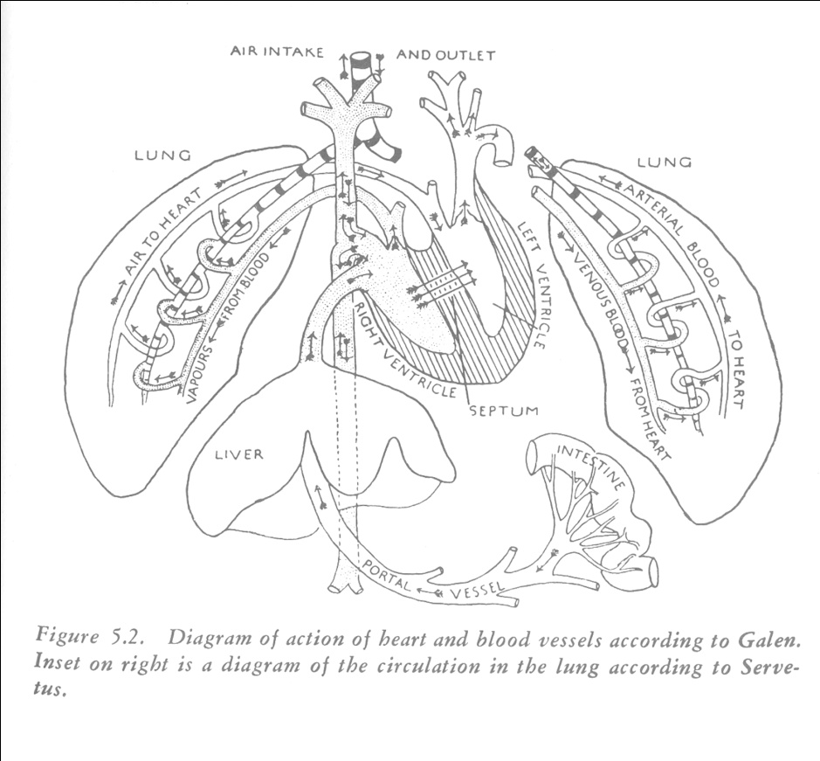
ISLAMIC discovery of the “lesser” or pulmonary circulation”:

Discovery of the pulmonary circulation by Ibn al-Nafis (d. 1288) who worked in a Cairo hospital. Contrary to the Galenic idea of the passage of blood from the right ventricle of the heart directly through the “invisible pores” in the septum, al-Nafis states that no blood could pass through the spetum and has to pass through the lungs into the left part of the heart. He was the first one to propose pulmonary circuit of the blood.
What was the methodology? Dissections of human bodies were prohibited in Islam, so most of the work on vision and pulmonary circulation were presumably based upon clinical observations plus inferences (or guesses) about what could be the physiology behind the observed phenomena.
Who was William Harvey : a slightly younger contemporary of Galileo (1564-1642)
[From Wikipedia} William Harvey (1 April 1578 – 3 June 1657) was an English physician who was the first person to describe completely and in detail the systemic circulation and properties of blood being pumped to the body by the heart. After his death "The William Harvey Hospital" was constructed in the town of Ashford, several miles from his birthplace of Folkestone.
Harvey's initial education was carried out in Folkestone, where he learned Latin. He then entered the King's School (Canterbury). Harvey remained at the King's School for five years, after which he joined Caius College in Cambridge.
Harvey graduated as a Bachelor of Arts from Caius College in 1597.^{[2]} He then traveled through France and Germany to Italy, where he entered the University of Padua,in 1599.
During Harvey's years of study there, he developed a relationship with Fabricius and read Fabricius' De Venarum Ostiolis.
Harvey graduated as a Doctor of Medicine at the age of 24 from the University of Padua on 25 April 1602. It reports that Harvey had
"conducted himself so wonderfully well in the examination and had shown such skill, memory and learning that he had far surpassed even the great hopes which his examiners had formed of him."^{[3]}
He attended Padua University at the time when Galileo was a young professor there.
On his return to Britain, he became a fellow the Royal College of Physicians and was appointed as the physician to James I and held a similar position under Charles I.
His major work on the circulation of blood
He published his famous work titled (in English translation of the original in Latin) An Anatomical Essay concerning the Movement of the Heart and of the Blood in Animals in 1628. It was a poorly printed volume of only 72 pages.
When it was published, it was hailed as one of the notable scientific events of the century. His contemporaries were fully aware of the primary importance of his reformulation of human and animal physiology. Harvey himself claimed that he was offering a revolutionary new idea and that while many “distinguished and learned men” have looked at human anatomy, he is the only one “ to challenge the tradition and to assert that blood travelled along a previously unrecognized circular pathway of its own.
Harvey’s revolutionary idea: Circulation of blood
Harvey’s great discovery was the demonstration that the heart, the arteries and veins constitute a circulatory system. His findings were based upon on a combination of vivisection, visual observation and experimentation on more than 80 species including mammals, snakes, fish, lobsters, toads, lizards, slugs and insects.
He began by reversing the accepted understanding of heart’s motion. By observing dogs in vivisection, especially when the heart slowed down approaching death, he decided that the active motion of the heart is contraction, or systole. In systole, the heat gets tense with its apex thrust against the wall of the chest. Galen, in contrast, had considered diastole, or expansion, as the crucial motion when the heart filled up, or drew a quantity of blood into itself.
The next question he answered was what happened to the blood when in the heart? Valves at the entrance of each ventricle are arranged in such a way that the blood cannot flow back into the passage by which it enters and valves at the exits prevent it from re-entering again once it has left the ventricle. Each time the heart contracts, it pushed out a new quantity of blood into the arteries. It is the existence of the valves that led Harvey to compare the heart to a “water bellow” or a pump.)

To these mechanical considerations, Harvey added a new element : quantification. What Harvey did was to determine, by empirical measurements, the capacity of the heart in humans, dogs, sheep. Then by mulitiplying this number by the pulse rate, he computed how much blood is transferred from the heart to the arteries – approximately 83 pounds of blood, every half an hour, for an average adult man. (note: seems too much to me, but that is the reported figure).
From these figures, Harvey concluded that the heart was pumping out far more blood than could possibly be provided by the ingestion of food and this volume could only be explained by “return through a circuit.” (it used to be thought that blood gets spent as it nourishes the tissue). Harvey showed that so much blood left the heart per minute that it could not conceivably be absorbed by the body and continually replaced by blood made in the liver from chyle. This quantitative evidence established that the blood must constantly move in a circuit, otherwise the arteries and veins would simply explode under the pressure.
What he could not do was to display the complex pathways of the circular motion. He could not see with naked eye the minute connections – the capillaries – between arteries and veins. (Later shown by ). But by a simple experiment, he showed that a connection MUST exist.
Applying what is called a perfect ligature to his own arm, he cut off both veins and the artery. The arm gradually grew cold. Above the ligature, the artery filled and throbbed with blood. Looseing the ligature enough to free the artery while keeping the veins blocked, he felt a surge of warmth as fresh blood poured into his arm. Immediately he saw that the veins below the ligature swelled up. They had not been filled from the venous system which had remained cut off – the blood HAD to reach the veins through the arteries, thus proving that arteries and veins connect with each other and blood circulates through a net work of these vessels.
Vitalism of Harvey:
WH’s work looks very modern: experimental and quantitative. But that is only half the story. Even though he imagined the heart as a mechanical device, what drove the machine were vital spirits. He imagined the function of blood in the same Galenic/Hippocratic fashion, i.e., to transport “vital spirit” to the body. He saw blood as a spiritual substance. He likened the heart to the sun- as the center of the human body, and the giver of life etc. By and large, he accepted the teleological view of life.
2. “Iatro-mechanics” or bio-mechanics.
Under the influence of mechanical philosophy, a school of mechanical biology, or iatromechancis developed in the 17th century which made important contributions to anatomy and physiology.
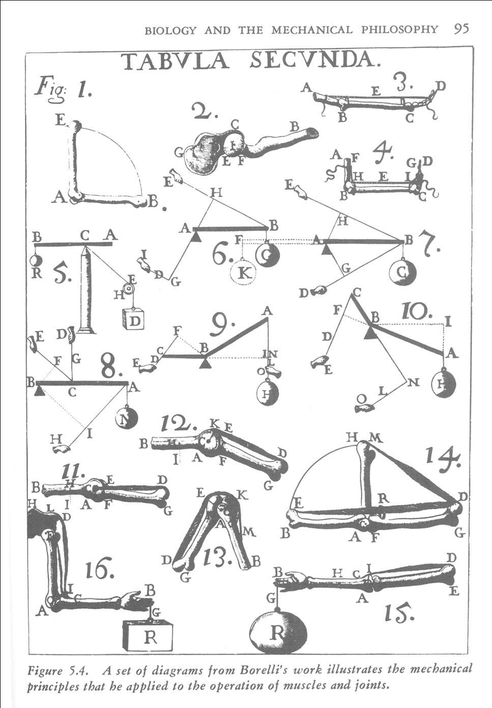
De Motu Animalium (The motion of animals) was published in 1680 by Alfonso Borelli (1609-1679). First for man, and then for other animals including birds and fish, Borelli applied the principles of mechanics to the analysis of various movements (see the picture above from the book). Consider a man crouched and ready to spring into the air. Borelli examined the position of the muscles that must contract and their connections with the skeleton. He treated the bones as levers and the joints as fulcrum.
Other contribution of Iatro-mechanics:
- Harvey’s work opened up more challenges. Iatromechanics calculated the velocity of blood and the resistance offered by different kinds of blood vessels.
- They proposed to explain animal heat as a result of friction of blood against the blood vessels.
- Theory of secretion based upon velocity of fluid
The importance of iatro-mechanics is the growing willingness on the part of biologists to imagine the boy as a “hydraulic machine … in which there are numerous tube for conveyance of fluids of different kinds. Health in this view depended upon keeping the fluids moving smoothly…

