Lecture 11, HSS102
Feb 19, 2016

The Alexandrian School: Mathematics, Astronomy and Anatomy

Timeline

Alexander (“the Great”) begins his conquest 344 bce
The city of Alexandria is founded in Egypt 332 bce
Alexander reaches India 327 bce
Death of Alexander 323 bce

Alexander’s Empire:

After Aristotle, the seat of learning gradually shifts from Athens to Alexandria, a city in Egypt founded by Alexander the Great in 332 BCE. Alexandria was home to the ancient world’s largest library and museum where many of this era’s best scientists worked. In this lecture we will look at the important developments in mathematics, astronomy and human anatomy that took place in the Alexandrian period which lasted from around 300 bce to just before the birth of Christ.

The Founding of the city of Alexandria:

One of Aristotle’s students, Alexander, the young king of Macedon, embarked upon a military campaign to win the entire world known at that time.

Alexander had been crowned the king of Macedonia in 336 bce at the age of 20, and by 332 bce, he had conquered Greece, Asia Minor (today’s Turkey) and Egypt. In 327, after having conquered regions of what is Afghanistan today, his armies crossed the river Jhelum. This is where the famous battle with Porus took place: Porus lost, but Alexander was impressed with his bravery and made him a gift of an extended territory. He was all set to cross the Ganga into the Northern plains of India, but his army refused to keep on fighting. He went along the Indus river back to Afghanistan and further West. Alexander’s invasion of this region left an enduring Greek influence on art and architecture: the Buddha statues in Bamiyan, for e.g., had pronounced Greek features.
The city of Alexandria was founded by him. It is located on the Mediterranean Sea, near the mouth of the river Nile. Alexander is supposed to have planned it himself and he intended it to be the most magnificent city in the world. But he stayed there for a very brief time. The city was built by his ministers and deputies.

After his death in 323 bce, his empire was divided up and Egypt fell to a line of kings called the Ptolemy who ruled until the conquest of Egypt by Rome in 80 bce by Octavian, and became a part of the Roman Empire. (The fabled queen Cleopatra was a part of the Ptolemy dynasty).

The Library of Alexandria
The Ptolemy kings were interested in cultivating sciences and arts. They decided to created what they called a “Musaeum” ( which literally means “a temple for the muses, or thoughts”. This word is the source of what we today call a “museum”). The great library of Alexandria was a part of the complex of institutions that made up the Musaeum.

The Musaeum was roughly modeled on Aristotle’s Lyceum (as the first Ptolemy king had studied with Aristotle.) and had all kinds of facilities including a botanical garden, a zoo and an observatory for star-gazing. At its peak, the library had some half-a-million scrolls.

The books and the collection of animals and plants were obtained during Alexander’s military campaigns. Alexander took with him an army of surveyors, engineers, geographers and other scientists of that era. They were under orders to collect any useful knowledge and any interesting specimen of plants and animals they came across. These collections used to be first sent to Lyceum where Alexander’s guru Aristotle taught. Afterwards, these collections were sent to the Museum and the Library at Alexandria. The Ptolemy kings also used to send out agents to buy or borrow texts from all corners of the empire which they used to make copies of. So the library was truly well-stocked.

The Museum and the library became the best known center of learning in the ancient world and continued to exist for nearly 600 years until it was completely destroyed by the Roman emperor Theodosius in 391 CE. Theodosius was a Christian fanatic and who found the pagan learning of the Greeks and pre-Christian civilizations “un-Christian.” The library had also suffered massive fire damage in 60 BCE during a military adventure of Julius Ceaser.

  - Science at the great Museum and Library of Alexandria
The Ptolemy kings made all attempts to attract the best scholars from all over the world to the library. Thus most science of that era was either conduced at the library, or had some connection with the library. Nearly all the scientists whose work we will look at had some connection with Alexandria.

Advances in Mathematics and Astronomy in the Alexandrian Age
  - Euclid (330-275 BCE)
The Alexandrian school produced two of the most famous mathematicians whose works are still relevant after more than 2,000 years: Euclid and Archimedes.
Euclid is often described as the “father of geometry” and his book called the Elements has undergone more than a 1000 reprints since the invention of the printing press. It is supposed to be one of the most long-lasting and influential textbook of mathematics ever.
Not much is known about Euclid except that he was Greek, born in 330 bce and died in 275 bce, same age group as Eudoxus, but older than Archimedes. It is possible that he might have studied at Plato’s Academy. But it is certain that he lived and worked in Alexandria.
In Elements, Euclid compiled all the mathematics known in his day: Books I and II of Elements deal with Pythagoras, Book IV the work of Eudoxus and so on (there are 13 books that make up the Elements.)
But Euclid was not just a compiler: his genius lay in presenting mathematics in a single, logically coherent framework that used the method of deductive logic to derive new theorems from already accepted definitions and axioms.
The Book I of the Elements begins with 23 definitions, some of which are as follows:
Definition 1.
A point is that which has no part.
Definition 2.
A line is breadthless length.
Definition 3.
The ends of a line are points.
Definition 4.
A straight line is a line which lies evenly with the points on itself.
Definition 5.
A surface is that which has length and breadth only.
.
.
. Definition 11.
An obtuse angle is an angle greater than a right angle.
Definition 12.
An acute angle is an angle less than a right angle.
.
.
Definition 23
Parallel straight lines are straight lines which, being in the same plane and being produced indefinitely in both directions, do not meet one another in either direction.

The definitions are followed by five postulates, and five axioms. (Postutlates and Axioms are self-evident truths that require no further proof. (Postulates are self-evident truths that are relevant to geometry only, while axioms apply more generally. )
Postulates:
Postulate 1.
A straight line can be drawn from any point to any point.
Postulate 2.
A finite straight line can be extended continuously from either end.
Postulate 3.
A circle of any radius can be drawn about any point.
Postulate 4.
That all right angles equal one another.
Postulate 5.
That, if a straight line falling on two straight lines makes the interior angles on the same side less than two right angles, the two straight lines, if produced indefinitely, meet on that side on which are the angles less than the two right angles.

Axioms (or “Common notions”) which are accepted as true without any proof or explanation:
Common notion 1.
Things which equal the same thing also equal one another.
Common notion 2.
If equals are added to equals, then the wholes are equal.
Common notion 3.
If equals are subtracted from equals, then the remainders are equal.
Common notion 4.
Things which coincide with one another equal one another.
Common notion 5.
The whole is greater than the part.

[source for above: http://aleph0.clarku.edu/~djoyce/java/elements/bookI/bookI.html#defs]

These definitions, postulates and axioms prepare the ground from which the rest of the propositions in 13 books are derived. A typical proposition begins with simply stating the proposition, followed by an example, followed by a proof and a conclusion. What is important to note is that the conclusions of a Euclidean proof follow necessarily from definitions, postulates, axioms and previously proven propositions (or in other words, proofs of propositions are deduced from definitions, postulates, axioms etc.).
It is this method of deductive proof made Euclidean geometry so influential for later history of mathematics.

  - Archimedes (287-212 BCE)
Euclid was followed by a series of brilliant mathematicians, the best-known being Archimedes (287-212 bce). He was born in Syracuse, a city-state on the island of Sicily in the middle of the Mediterrarean Sea. He studied in Alexandria. His teacher there was a student of Euclid and therefore Archimedes was well-trained in Euclidean ways of thinking.
Archimedes belongs to a new class of literate engineers that was beginning to emerge in antiquity. These were people who worked with their hands – mechanics, craftsmen, engineers – yet who were well-versed in the science of their times.
Most people associate Archimedes with the “Eureka” story about how he went running naked through the town yelling “Eureka” ( “ I got it…” )
It is important to understand what exactly had Archimedes discovered that he was so thrilled about.
The basic story is well-known: the king Hiero asked Archimedes to find out if his gold crown was pure gold, or if the jeweler had added silver to it. Archimedes was supposed to find out without damaging the crown by taking a sample from it.
One way to figure it out would be to weigh the crown: Gold is known to be more dense than silver –i.e., same volume of gold will weigh more than silver. So it is fair to reason that a pure gold crown would weigh more than a crown of the same size with both gold and silver. But the crown weighed the same as the block of gold that the king had given the jeweler.
What to do?
It was possible that the jeweler could have added just the right amount of silver to make the crown weigh the same as the gold he was given. In that case, given the fact that silver is less dense, the contaminated crown would have to be larger in volume. If the crown took up the same space as an equivalent weight of pure gold, then it was made of pure gold; but if it took up more space than the equivalent weight of gold, then it was formed of an alloy.
So the problem was how to measure the volume of the crown which had a highly irregular shape.

Archimedes’ Eureka moment in the bath-tub had to do with realizing that the crown’s volume could be measured by immersing in a vessel full of water and measuring the overflow.
When he stepped into the bathtub, he saw that his body displaced water. It splashed over the rim onto the floor. The deeper he immersed his body into the tub, the more water was displaced. That made his realize that the water he displaced was equal in volume to the part of his body that was under water.
He further thought – quite reasonably – that his body and the chunk of gold will behave in a similar way when immersed in water: ANY object, when immersed in a liquid will displace a volume of liquid equal to the object’s own volume.
So all he had to do was to immerse the crown into a vessel of water and meaure the water it displaced. Then he immersed a piece of pure gold the same size the king had given to the goldsmith.
He found that the crown displaced more water than the pure gold. That meant that the crown had larger volume than pure gold of the same weight. The crown had been adulterated with silver.
The “Eureka!” story has become a part of the legend of Archimedes, and it is possible that Archimedes got excited enough to run naked in the street when the idea first came to him in the bath-tub. But, it was pointed out nearly 1000 years later by Galileo(in 1600 ce) that simply dipping the crown and the pure gold in water and measuring the volume of spilled water was too imprecise: the difference in the volume of overflow produced by immersing pure gold and an adulterated one would have been too minute for precise measurement. Galileo thought that Archimedes who he admired enormously and called a “divine man” was smarter than that. So Galileo – when he was 20 years old – wrote his very first scientific pamphlet which he called “The Little Balance” (or La Bilancetta in Italian) in which he proposed how Archimedes could have accurately measured the difference. What Galileo described was an accurate balance for weighing things in air and water, in which the part of the arm on which the counter weight was hung was wrapped with metal wire. The amount by which the counterweight had to be moved when weighing in water could then be determined very accurately by counting the number of turns of the wire, and the proportion of, say, gold to silver in the object could be read off directly. (see ppt).
Having read Archimedes treatise “On Floating Bodies”, Galileo suggested that he probably used the principle of buoyancy to compare the density of the golden crown to that of solid gold by balancing the crown on a scale with a gold reference sample, then immersing the apparatus in water. The difference in density between the two samples would cause the scale to tip accordingly. Galileo considered it "probable that this method is the same that Archimedes followed, since, besides being very accurate, it is based on demonstrations found by Archimedes himself." This is how the balance would have worked:
The balance will tilt toward solid gold when dipped in water.
Other writings from the Middle Ages also refer to such a balance: In a 12th-century text titled Mappae clavicula there are instructions on how to perform the weighing in water in order to calculate the percentage of silver used, and thus solve the problem. The Latin poem Carmen de ponderibus et mensuris of the 4th or 5th century describes the use of a hydrostatic balance to solve the problem of the crown, and attributes the method to Archimedes.
Archimedes principle of buoyancy:
Archimedes Eureka” was not limited to the crown. In fact, he wrote an important book on floating bodies in which he gave a mathematical description of what is today known as the principle of buoyancy, or Archimedes Principle.
Floatation of any object is determined by two opposing forces: gravity which tends to pull an object down, and buoyancy, which tends to push it up.
Whether an immersed object will sink or float depends upon which of the two opposing forces is larger: if the weight of an immersed object is greater than the upward buoyancy force, it will sink, but if the upward buoyance is greater, it will float. That is why a stone sinks but an ice-cube floats: for the same volume, a stone has more weight than the ice-cube. A fish can swim at any level within the water where its weight and buoyancy are balanced. A submarine can dive by filling its ballast with seawater and becoming heavier, while it can float by pumping out the seawater.
A body partially or completely immersed in a fluid is lifted up by a force equal to the weight of the displaced liquid.
Thus, a body wholly or partially immersed in a fluid will appear lighter by the weight of the fluid it displaces.
With this principle, the contest of forces governing floatation of a body is completely determined: the object’s weight can be measured on a scale, while the buoyant force on it can be linked to its volume. The larger the volume, the more buoyancy the object will experience.
  - Apollonius
The third great mathematician from this period is Apollonius of Perga, who is chiefly celebrated for having produced a systematic treatise on conic sections.
He was born about 260 bce and died in 200 bce. He studied at Alexandria and perhaps taught there. He was a contemporary of Archimedes.
Euclid geometry followed Plato’s teachings that allowed only the use of a ruler and a compass for drawing geometrical figures. This meant that Euclid missed some special curves – ellipses, parabolas, hyperbolas etc. – which cannot be drawn with a compass. These curves can be studied by cutting through conic structures.
That is what Apollonius accomplished: He described the geometry of conic structures.
For a long time, these structures played no role in physics and were considered mathematical curiosities. But Galileo discovered the path of a canon to be a parabola and Kepler the path of planets to be elliptical. After that, this branch of geometry became increasingly important in physics.
  - Eratosthenes (275-195 bce)
Eratosthenes (275 bce to 195 bce) was often called “Beta” to the “alpha” who was Aristotle himself. In other words, Eratosthenes was second only to Aristotle in talent and importance.
Eratosthenes was born in Northern Africa (now Libya) and was invited by Ptolemy to become the director of the library at Alexandria.
Today he is remembered most for his measurement of the circumference of the earth which he calculated with a remarkable accuracy using simple geometry. This is how he did it:
He knew that on noon time on the summer solstice day in a city called Syene (modern day Aswan in Egypt), the sun was directly overhead. How did he know that? Because:
- There is no shadow. If you stand there in the sun at noon on June 21, you will have no shadow at all.
- That is the only time when the bottom of a very deep well is lit up.
But Eratosthenes observed that in Alexandria, the city where he lived, where at the same time of the day, the sun **did** cast a shadow, i.e. was not directly overhead.
So he did a simple measurement: he stuck a stake in the ground in Alexandria and measured the angle of its shadow at noon: it came to 7.2 degrees which is about 1/50th of 360 degrees of a circle (which he assumed the earth was).
He drew an imaginary line that continued the shadow at Alexandria to the center of the earth. Simple geometry told him that the angle at the center is the same as that in Alexandria. So he thought that if the earth is truly a globe, then the distance between Alexandria and Seyene is 1/50th of the earth’s circumference. To find the size of the whole globe, all he had to do was to measure the distance between the two cities and multiply it by 50.

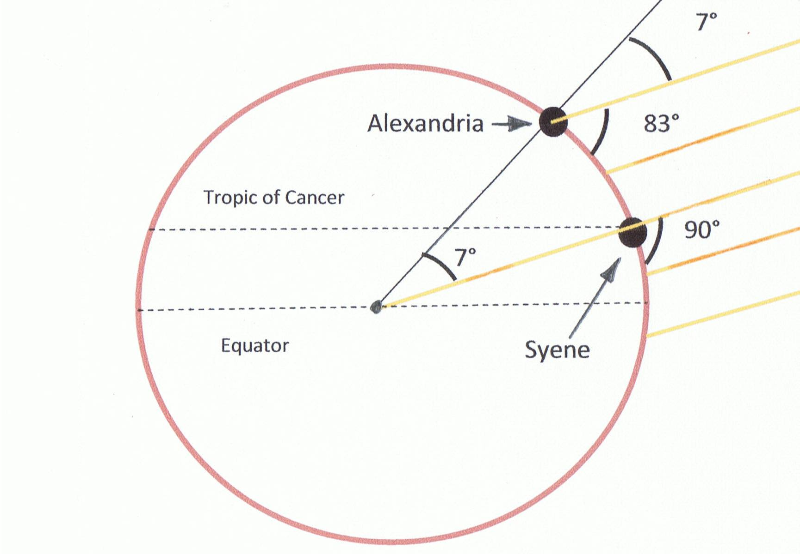
The distance between the two cities was known to be 5,000 stadia. (this figure was arrived at by camel-driven caravans that plied between the two cities. The legend is that he paid someone to walk the distance and count the steps).
So he calculated the earth’s circumference to be 50X5,000= 250,000 stadia.
It is not clear how long a stadia was supposed to be. The best guess of modern experts is that a stadia in those days measured close to beteen 150-158 meters. So at 157 meters, Eratosthenes measurement would come to around 39,250 kilometer (or 24,390 miles). This figure is actually very close to todays’s measurement of about 40,000 km (or 24,855 miles).

Advances in Medicine in the Alexandrian Period
  - Human dissections
Through most of human history, cultures all around the world have shown a deep reluctance to cut up human bodies: human remains are considered sacred and not available as material for cutting up. All religions and cultures prohibit desecration of human bodies. But in Renanissance Europe, human dissections were permitted. Here is a brief history of human dissections:
HUMAN DISSECITONS BEGIN in ALEXANDRIA THIRD CENTURY BCE: for a brief period, in the early Roman empire, human dissections were permitted. There are at least two major medical treatises dating back to that time that involved human dissections:
Heorphilus(approximately 255 bce), studied med on the island of Cos famous for Hippocratic tradition, moved to Alexandria and worked for the Ptolemaic kings.
- Investigated the anatomy of the brain, identifying two of the brain’s membranes, i.e. the dura matter and the pia matter.
- He traced the connections between the brain and the spinal cord.
- Dissected the human eye and identified the connection between the optic nerve and the brain
- Explored the organs of the abdominal cavity
- Distinguished veins from arteries by thickness of the walls.

ErasiSTRATUS (b. 304 bce): If Herophillus was more interested in structure, E was more interested in function. He studied
- The bicuspid and tricuspid valves of the heart. Explained it as a bellows, expanding to fill up with pneuma or air, inhaled from the atmosphere.
- Human physiology:
  - Food – turned into juice
  - Seeps through pores in the stomach to the liver
  - Where it is converted into blood
  - Blood carried by veins to all parts of the body
  - Arteries contain only pneuma, or air, which is supplied to the left side of the heart and then circulated to the entire body through arteries, supplying the body with vitality
  - Nerves contain a finer form of pneuma, a psychic pneuma, puriefied from arterial pneuma in the brain.
- Theory of disease: disease caused by flooding of veins with surplus blood caused, for e.g. by excessive eating. This opens up the channels between veins and arteries, pushing blood into them.
- The solution: reduce the blood, by cutting food or by blood letting.
After this brief period, there were no more dissections of human bodies.
  - Galen
Galen was to medicine and biology what Ptolemy had been to astronomy: His works were considered the bible of human physiology, disease and health up until the Renaissance.
His full name was Aelius Galenus or Claudius Galenus (b. 129 AD, d. circa 200 AD), but was better known as Galen of Pergamon. He was a prominent Roman (of Greek ethnicity) physician, surgeon and philosopher. Arguably the most accomplished of all medical researchers of antiquity, Galen contributed greatly to the understanding of numerous scientific disciplines, including anatomy, physiology, pharmacology, and neurology, as well as philosophy and logic. (Wiki)
He was born into a wealthy family of an architect and received a comprehensive education that prepared him for a successful career as a physician and philosopher. He traveled extensively, exposing himself to a wide variety of medical theories and discoveries before settling in Rome, where he served prominent members of Roman society and eventually was given the position of personal physician to several emperors. In 157, he was appointed a physician to gladiators, which helped him study whatever human anatomy he could see from wounds and cuts.
Galen saw himself as both a physician and a medical researcher. To aid his research, he performed many dissections and vivisections. Many of his works have been preserved and/or translated from the original Greek, although many were destroyed and some credited to him are believed to be spurious. Although there is some debate over the date of his death, he was no younger than seventy when he died.
Galen’s teachings:
On medicine: Galen saw himself as perfecting Hippocrates. He explained fever, the most common of ailments in humoral terms : it was due to excess of either yellow bile, black bile or phlegm or from an excess of blood. These surplus humors accumulated in some body part where they would cause putrefaction and excessive heat. To remove such superfluity and restore humoral balance, he advocated energetic blood-letting. Not only to cure diseases, but also as a preventive measure, galen recommended bloodletting from the veins.
On anatomy:
Galen saw himself as a medical scientist, and not just a physician. So he performed dissections, mainly of apes, sheep, pigs and goats, even of elephant heart, but NOT of humans: dissection of human bodies was not allowed in Rome when he worked there. He ended up extrapolating what he saw in animal dissections to human anatomy. Some of his observations --which will be overthrown – included the following:
- From dissection of calves, he found a network of nerves and vessels at the base of the brain. He theorized that this was the site where “vital spirits in the arteries was transformed into “animal spirit”
- From dissections of pigs and apes, he thought that the liver grasped the stomach, as if with its “fingers.”
- He believed that there were pores in the walls of the heart (called the ‘septum” that separated the right from the left side.
On physiology: Galen left behind a detailed account of the function of the heart, liver and lungs in the production of blood.
We will come back to Galen when we pick up the story with Vesalius in the 16th century.

