Finance and Accounts-APO User- Budget Addition

Overview
The purchase budget user applies budget to the purchase request.
E.g. For a purchase request, budget user applies budget after deciding that under which financial year and under which company and cost center this purchase request will be done.
Following activities are possible in purchase module:
- Addition of budget
- Viw/Remove applied budget

Addition Of Budget
When the purchase indenter creates a purchase request this request comes to the purchase budget user. Budget user can follow these steps to apply budget to purchase request:
- Login to Campuslabs ERP using your credentials.
- Select “Finance and Accounts-APO” role.
- Click on “Purchase Inbox” from left menu pane.
- The requests will be shown with “Requested” status in the Inbox(figure-1).
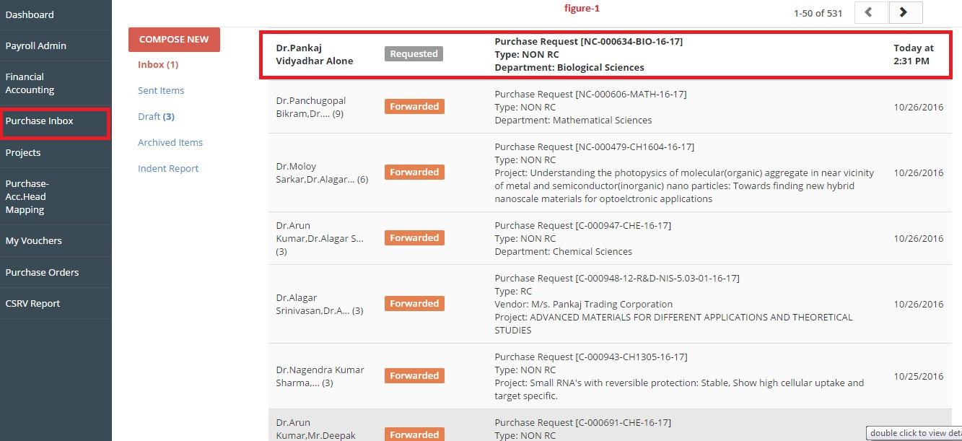

- Double click on the mail to open it.
- Click on “Click to fill Budget Details(only for accounts dept)” option as shown in figure-2.
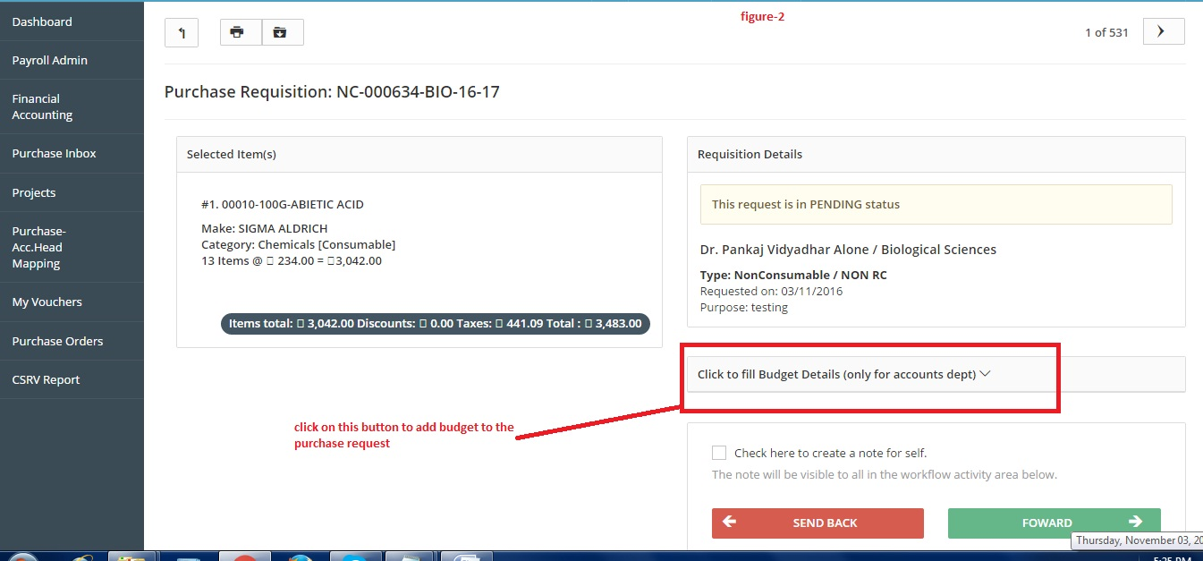

- Enter the relevant values in “Select Company”, “Select the Financial Year” and “Select the Cost center” fields(figure-3).
- Then click on “Apply” button to apply the budget to particular purchase request(figure-3).

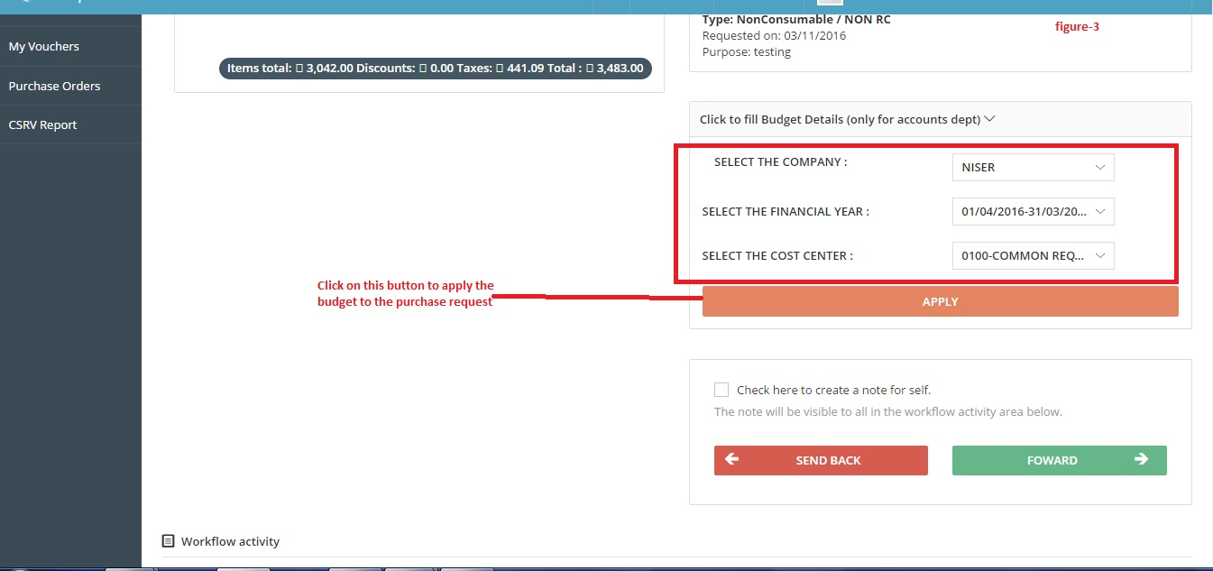

- Click on “Forward” button and select the person to whom you want to forward the request from “Forward this request to” dropdown(figure-5).
- Enter the comments in remarks field(figure-5).
- Click on “Send” button(figure-5).
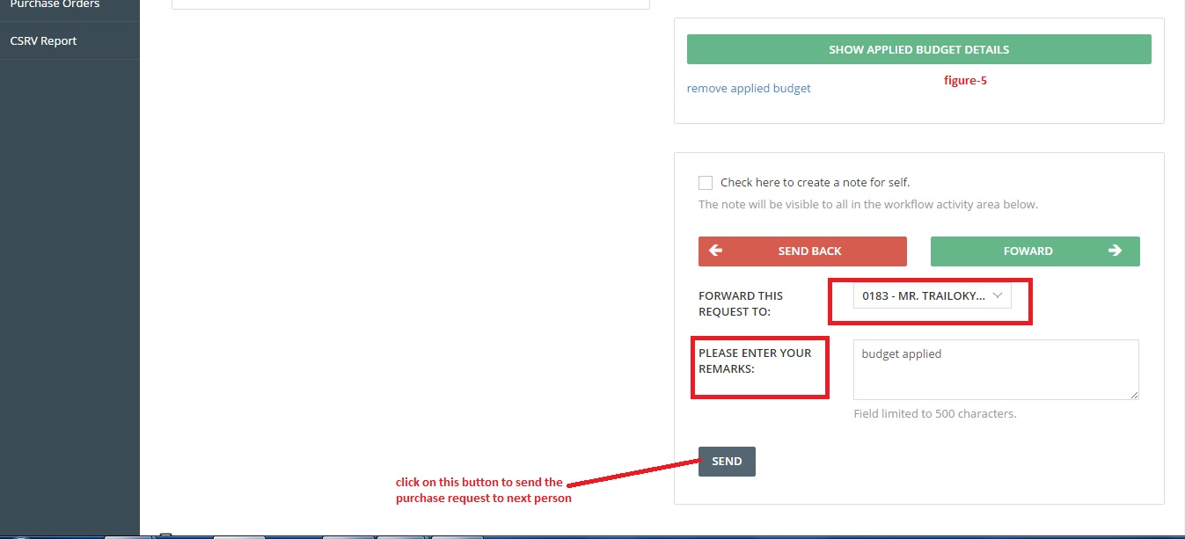

View/Remove Applied Budget
To check/delete applied budget follow these steps:
- Click on “Show applied budget details “ button to check the details of applied budget(figure-4).
- If you want to remove the applied budget click on “ remove applied budget” link(figure-4).
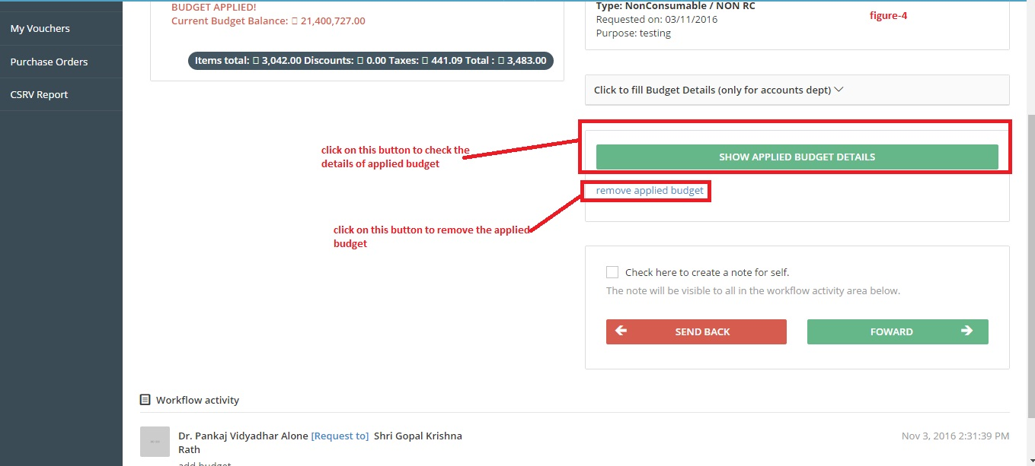

After this process the purchase request will be forwarded to related authority for financial approval.

