Finance and Accounts-APO-Payment Voucher Creation

Overview
The finance and accounts user use the purchase module for purchase related activities.

Steps To Create Payment Voucher
Finance and Accounts user can follow these steps to create payment voucher:
- Login to Campuslabs ERP using your credentials.
- Select “Finance and Accounts-APO” role.
- Click on “My Vouchers” from left menu pane.
- The requests will be shown with “Approved” status in the Inbox.
- Open the request by double clicking on it.
- Click on “Create Payment” button which resides on the top left corner of the mail , form for payment voucher creation will be opened (Figure- Create Payment button).
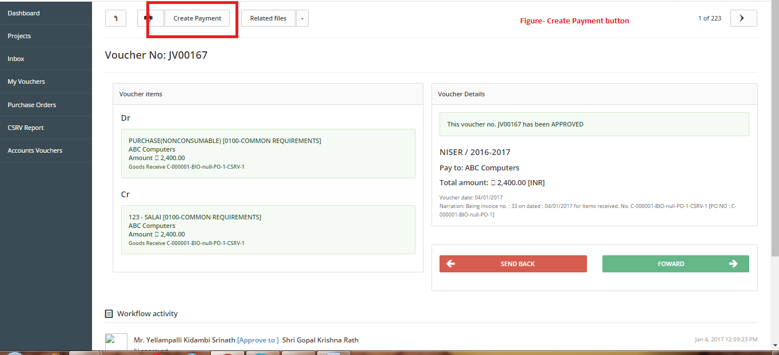
- Enter the details like bank, cheque number.
- Enter remark in “remark/narration” field (Figure-Save payment button).
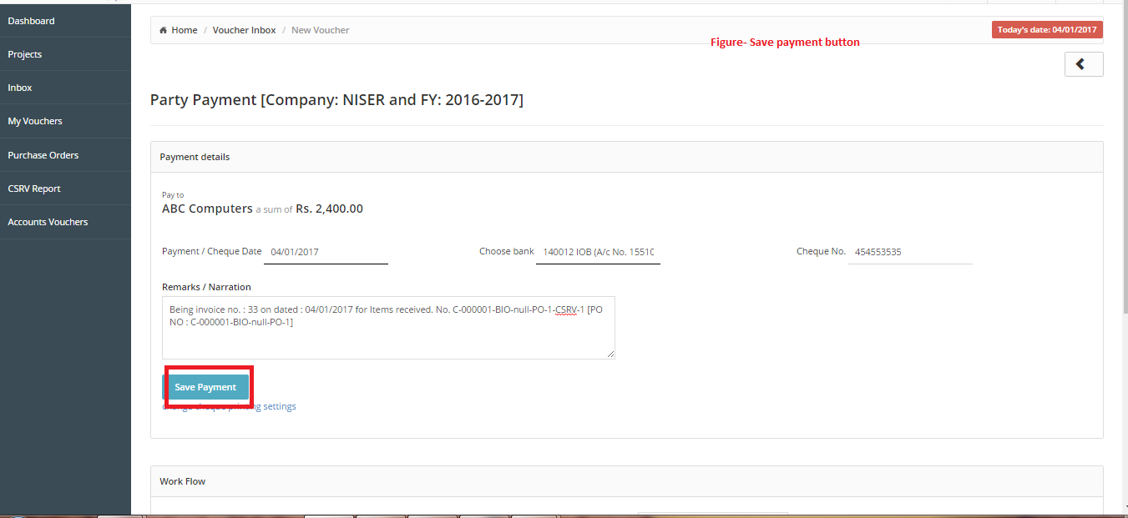
- Click on “Save Payment” button.
- As soon as you will click on “save payment” button one more field for bank selection and two buttons print cheque and print voucher buttons will be visible at place of save payment button.
- Select the bank name for format of cheque and click on print cheque button (Figure- New Fields).
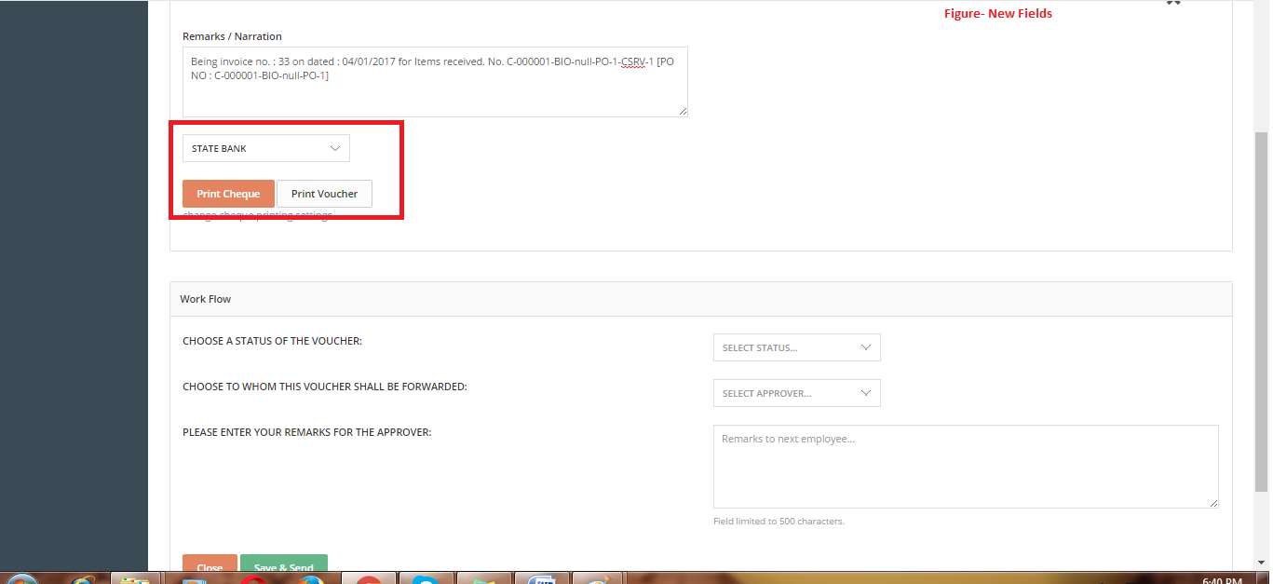
- The cheque will be printed on the selected bank’s cheque format.
- Select value from “Choose the status of the voucher” dropdown (Figure- Save and send button).
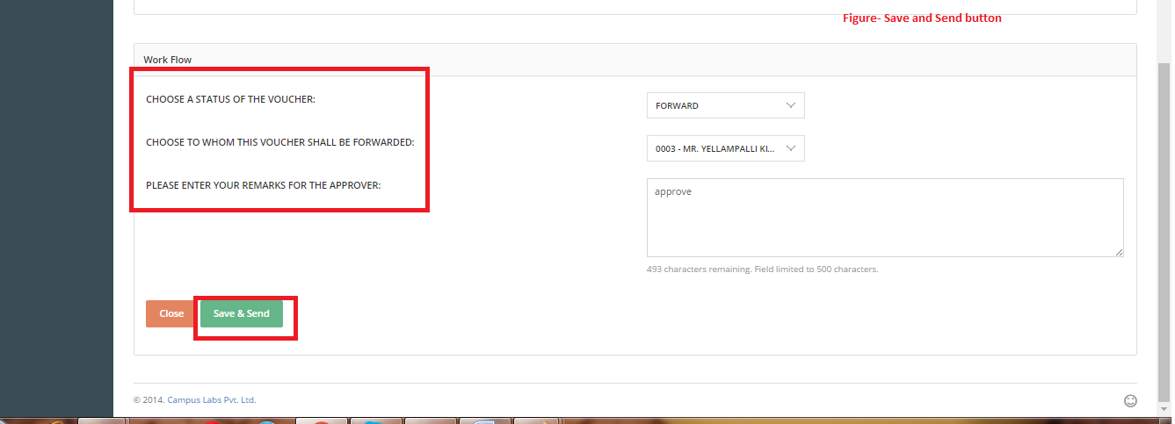
- Select next person from “To whom this voucher shall be forwarded” dropdown.
- Enter Remarks.
- Click on “Save & Send” button.
The Payment Voucher will be created and forwarded to next person.

