Finance and Accounts-APO-Forward Journal Voucher

Overview
The finance and accounts user can use the purchase module for purchase related activities.

Steps To Forward Journal Voucher
Finance and Accounts user can follow these steps to forward the request to next level:
- Login to Campuslabs ERP using your credentials.
- Select “Finance and Accounts-APO” role.
- Click on “My Vouchers” from left menu pane.
- The requests will be shown with “Requested” status in the Inbox.
- Open the request by double clicking on it.
- Click on “Forward” button (Figure-Journal Voucher Forward).
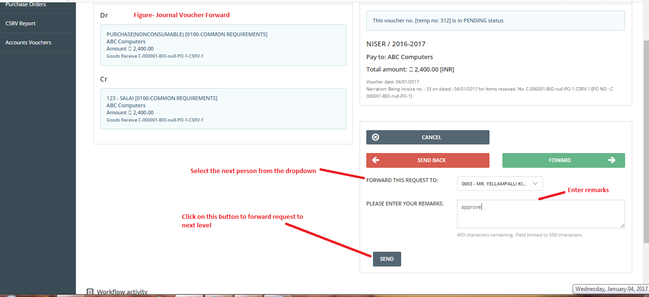
- Select value from “Forward this request to” dropdown.
- Enter Remarks.
- Click on “Send” button.
The Journal Voucher will be forwarded to next person.

