Voucher Approval Process

Overview
Voucher approver user can use Accounts model for voucher approval/rejection.

Following activities are possible in the Voucher Approval Model:
- Creation of new Voucher
- Edit voucher details
- Approve/Reject raised vouchers
- View details of approved/rejected vouchers
- View old vouchers

Creation of New Voucher
User can follow these steps to create new voucher:
- Login at Campuslabs ERP with your credentials.
- Click on “My Vouchers” from left menu pane (Figure-1).
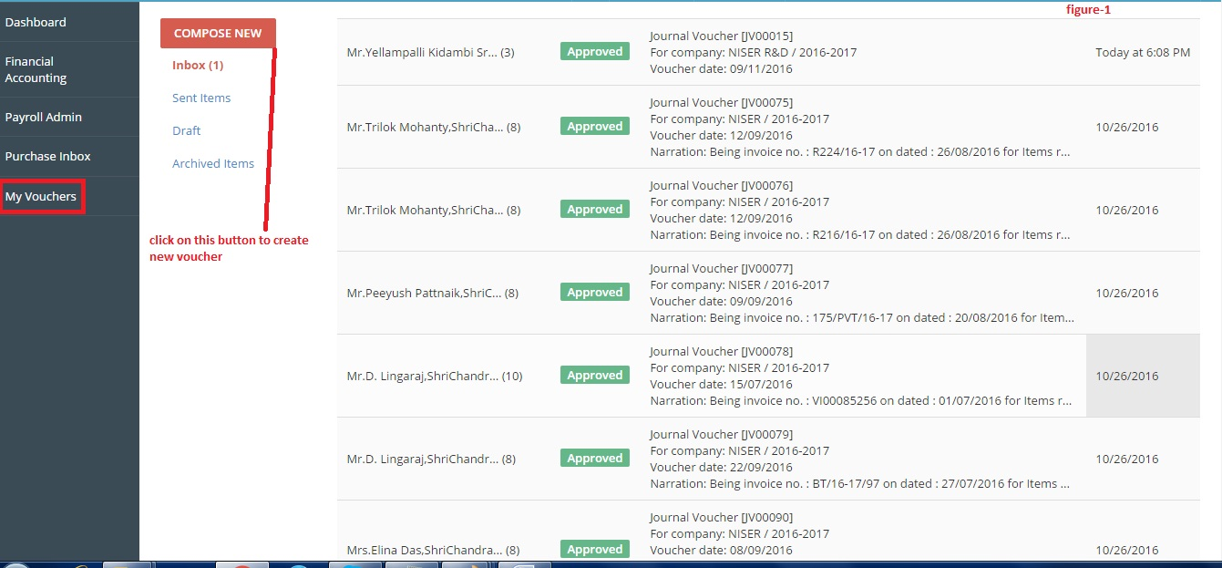
- Click on “Compose New” button.
- Wizard for creation of voucher will be opened (figure-2).
- Fill the details regarding the voucher in different forms of wizard.
Details of Forms:
- Initiate: You need to fill the details like which type of voucher you want to create and against which party, voucher creation under which company, voucher creation date etc.
- Transactions: You need to fill the details like Debit entry (debit to which account head, under which cost center, debit amount etc.), Credit entry (Credit to which account head, under which cost center, credit amount etc.).]
- Payment Instrument: You need to fill the details like pay to, cheque amount, cheque number, cheque date etc.
- Create Workflow: You need to select the status for voucher, person to whom the voucher shall be forwarded, remarks etc.
- Review and Submit: All the details filled in the previous forms of wizard are shown in this step of wizard. You need to review all the details and then click on “Save and Send” button.

- Click on “Save and Send” button to send it to the approver for approval (figure-3).

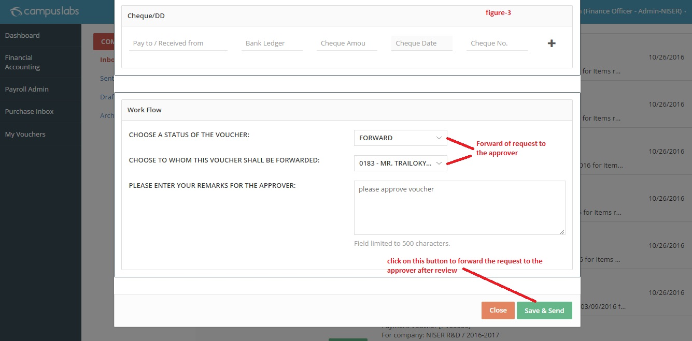

Edit Voucher Details
Vouchers are saved in Drafts if user does not click on “Save and Send” button in the last step of the wizard for voucher creation. A voucher is present for editing before click on save and send button. User can follow these steps to edit a voucher:
- Click on “Draft” option from the screen.
- Click on “Edit” icon to open the draft for edit purpose.
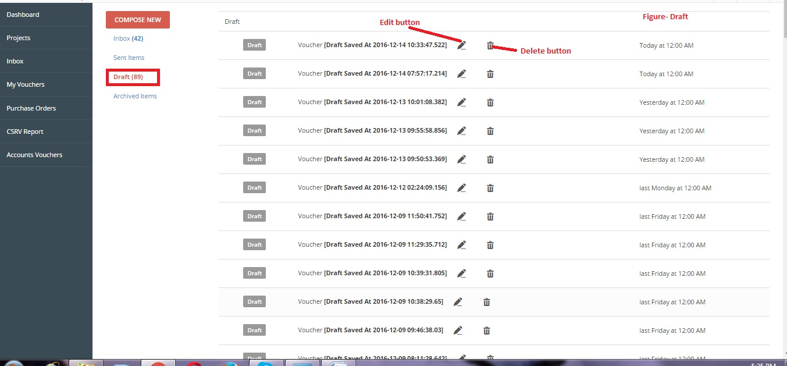
- The draft is opened with existing data from initiate step.
- User can change the values and then click on “Save and Send/Close” button will save the changes.

Approve/Reject raised vouchers
User can follow these steps to view the response of raised requests:
- Click on “Inbox”.
- All the response mails are shown here.
- You can open the mail by double clicking on the mail.
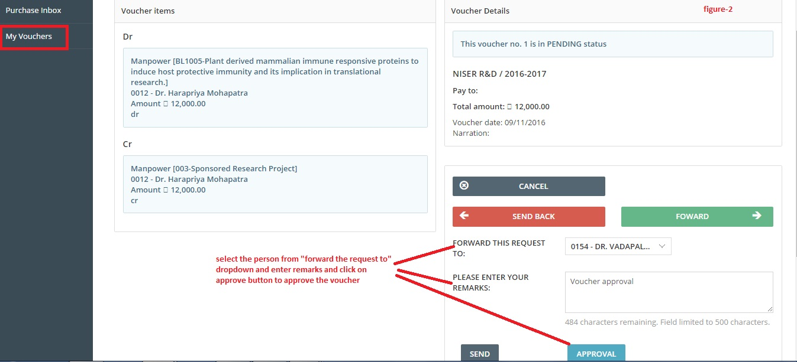
- Click on “Forward” button.
- Select the person from “Forward this request to” dropdown and enter remarks.
- Click on “Approval” button.
The Voucher is approved.

View details of approved/ Rejected vouchers
User can follow these steps for checking the details of raised requests:
- Click on “Sent Items”.
- All the sent mails/raised vouchers are displayed here.
- You can open the mail by double click on it.
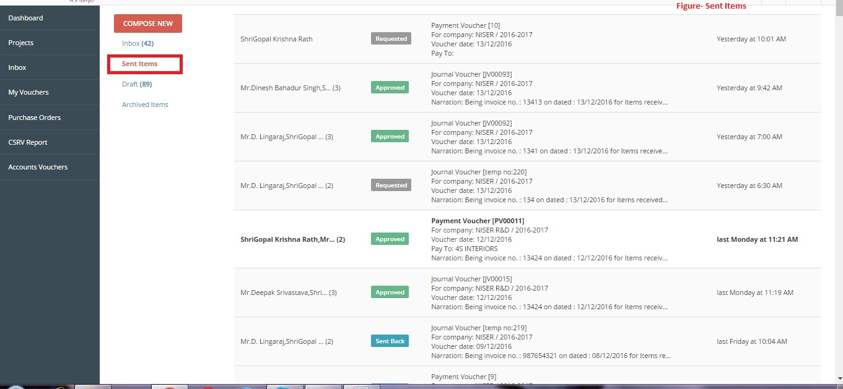

View Old Vouchers
User can follow these steps to check old vouchers details:
- Click on Archived Items.
- You can check old mails here.
- Double click on mail to open it.
