Finance Officer-Admin-Payment Voucher Approval

Overview
The finance and accounts approver user use the purchase module for purchase related activities.

Payment Voucher Approval
Finance and Accounts user can follow these steps to approve payment voucher:
- Login to Campuslabs ERP using your credentials.
- Select “Finance Officer-Admin” role.
- Click on “My Vouchers” from left menu pane.
- The requests will be shown with “Forwared/Requested” status in the Inbox.
- Open the request by double clicking on it.
- User can check payment details in the mail (Figure-Payment Details).
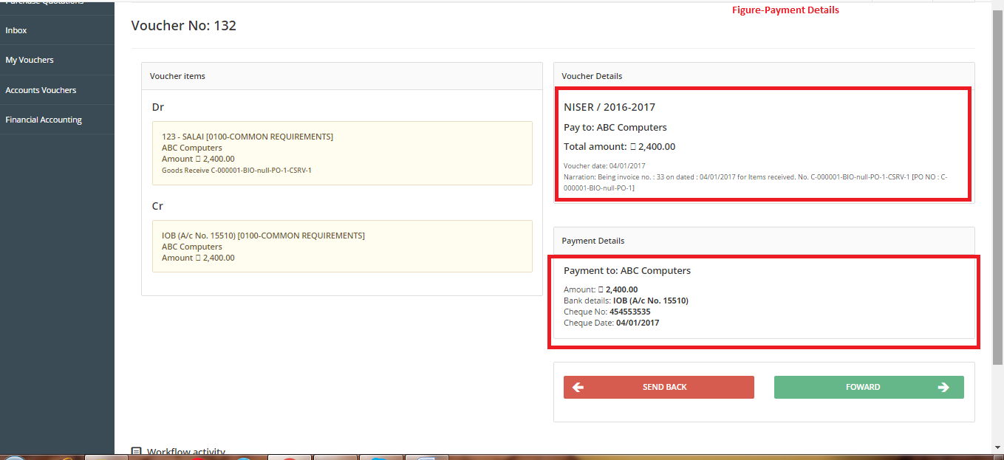
- Click on “Forward” button (Figure-Payment Voucher Approval).
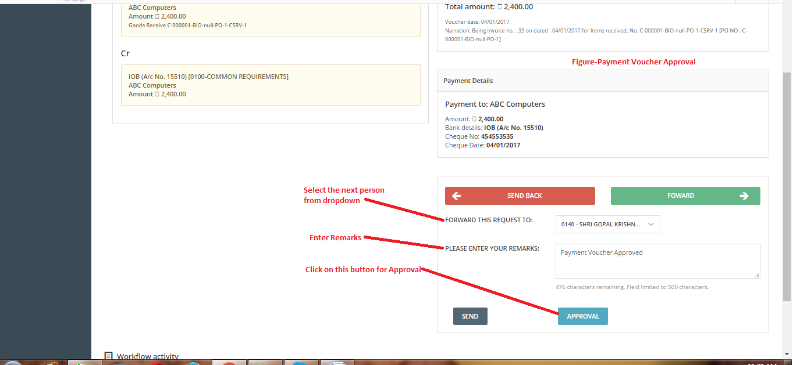
- Select value from “Forward this request to”dropdown.
- Enter Remarks.
- Click on “Approval” button.
The Payment Voucher will be approved and forwarded to next person.

