Finance Officer-Admin-Journal Voucher Approval

Overview
The finance and accounts user can use the purchase module for purchase related activities.

Journal Voucher Approval
Finance and Accounts user can follow these steps to approve journal voucher:
- Login to Campuslabs ERP using your credentials.
- Select “Finance Officer-Admin” role.
- Click on “My Vouchers” from left menu pane.
- The requests will be shown with “Requested” status in the Inbox.
- Open the request by double clicking on it.
- Click on “Forward” button (Figure-Journal Voucher Approval).
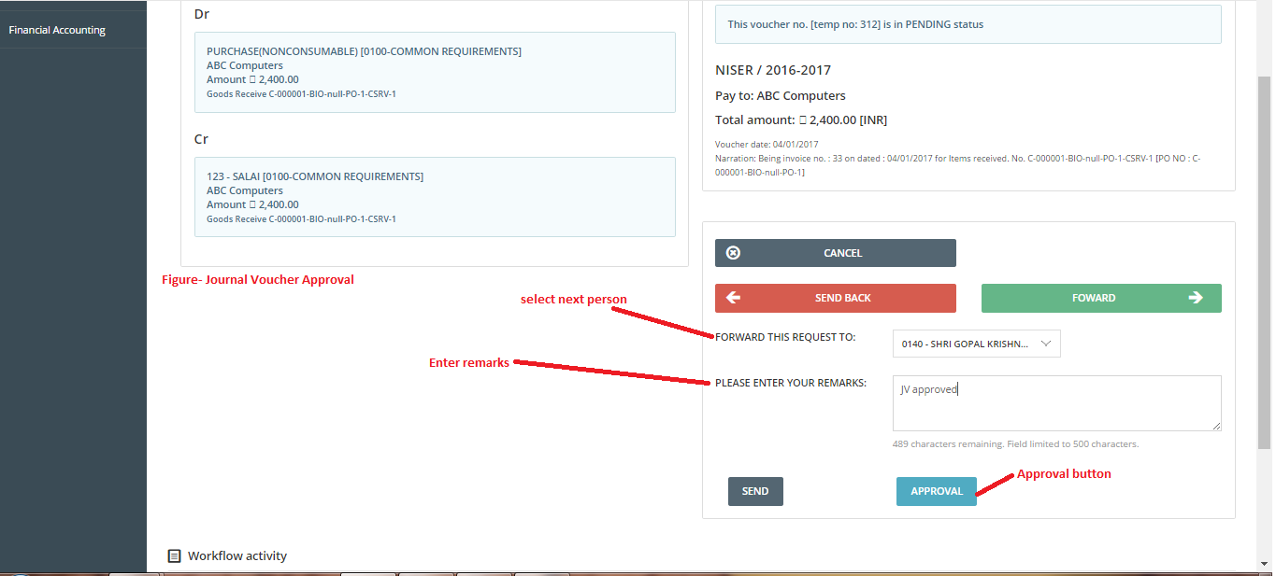
- Select value from “Forward this request to” dropdown.
- Enter Remarks.
- Click on “Approval” button.
The Journal Voucher will be approved and forwarded to next person.

