Accounts Admin-Financial Approval

Overview
Purchase financial user provides financial approval to a purchase request.

Process of Financial Approval
Financial user can follow these steps to approve a purchase request financially:
- Login to Campuslabs ERP using your credentials.
- Select “Accounts Admin” role.
- Click on “Purchase Inbox” from left menu pane.
- The requests will be shown with “Forwarded” status in the Inbox(figure-1).
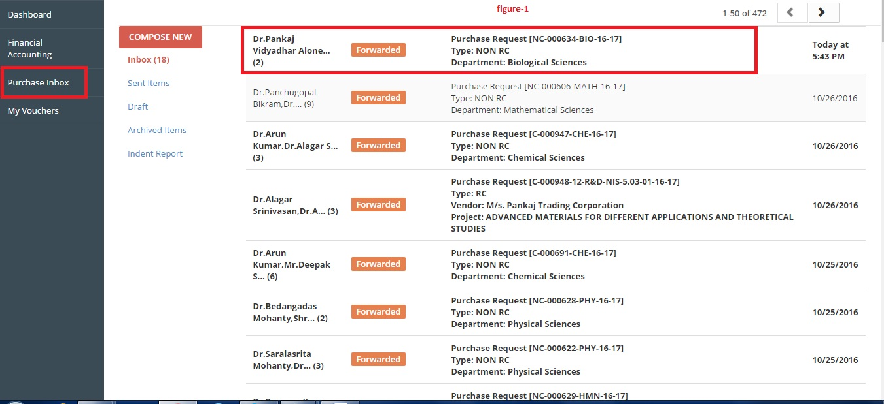

- Double click on the mail to open it.
- Click on “Forward” button and select the next person in the workflow from the “Forward this request to” dropdown, enter the remarks(figure-2).
- Click on “Financial Approval” button as shown in figure-2.

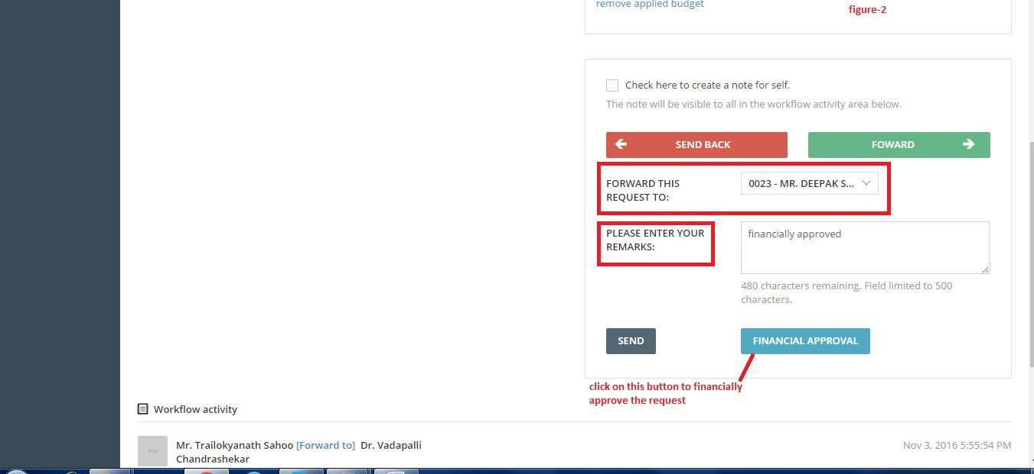

After this process the purchase request will be financially approved.

