Accounts Admin User

Overview
Accounts admin can use Accounts module for Accounts related activities.

E.g. Accounts admin can create master data, track the records through reports, several accounts transactions etc.

Following activities are possible in the Accounts Model:
- Creation of master data
- Accounts mapping
- Accounts Transactions
- Vouchers creation
- Financial Reports
- Financial Statements

Master Data: Data that is required/pre-requisite to drive functionality is known as “Master Data”.

Standard Steps:
User can follow standard steps to create/ Search any data in the model (Figure-1).
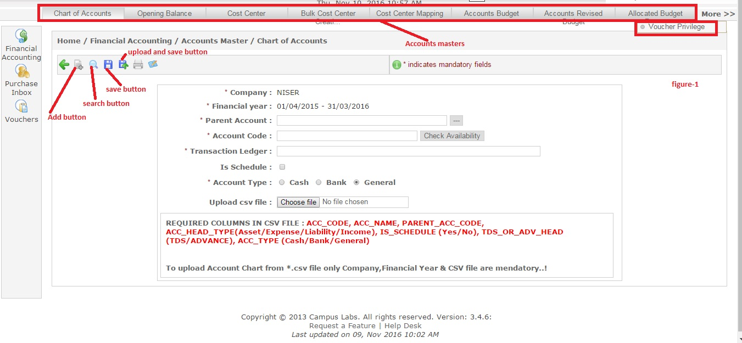

Steps for Creation:
User can follow these steps to create new data:
- Login at Campuslabs ERP with your credentials.
- Select “Accounts Admin” role.
- Click on “Financial Accounting” menu from left menu pane and select “Accounts Master” option.
- Click on “Charts of Accounts” tab from menu pane(which resides at the top of the screen).
- Click on “Add” button, form for new charts of account creation will be opened(Figure-Charts of Accounts Creation).
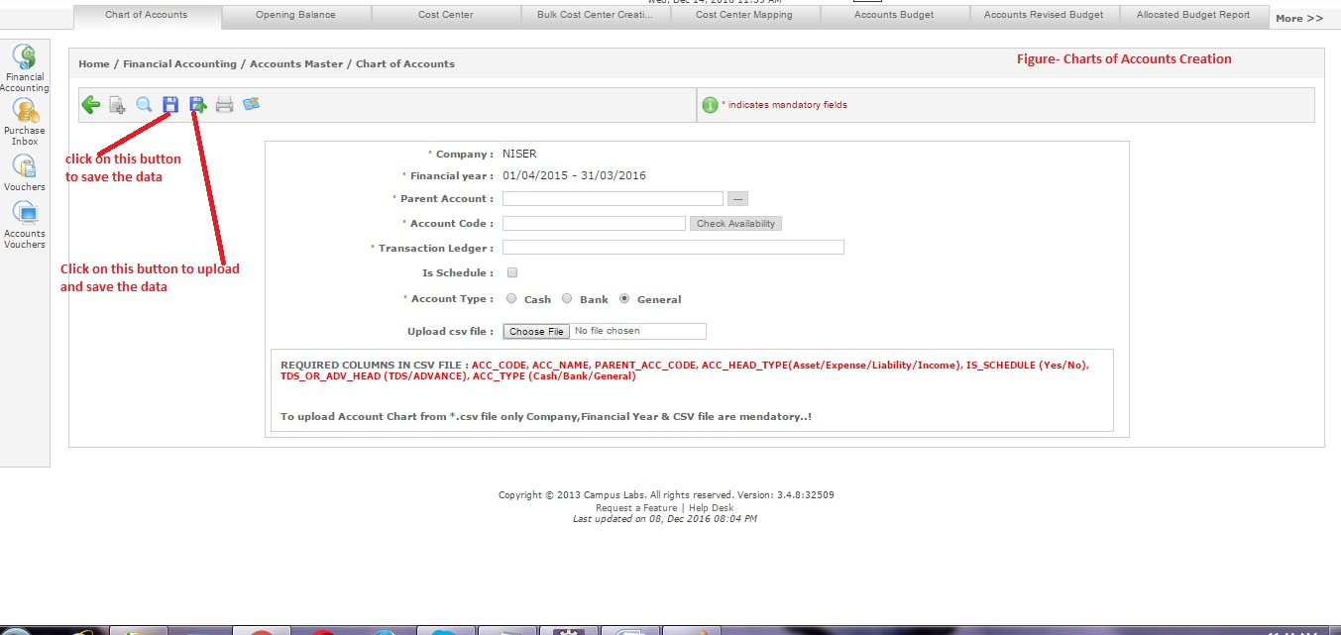
- Click on “Save” button to save the data and click on “Upload and Save” button when you need to upload any file and save the data.
New Chart of Account will be created after following these steps.

Steps of Searching:
User can follow the following steps to search data in existing data:
- Click on “Charts of Accounts” menu from top menu pane.
- Value for search filters is selected.
- Click on “Go” button to see the search results.
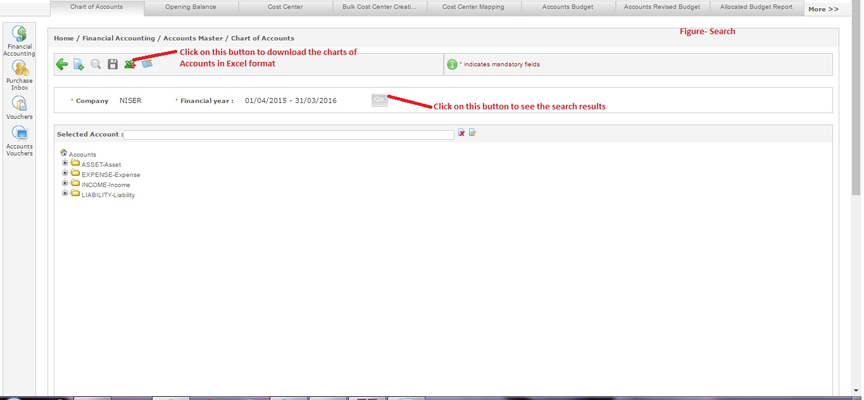

Steps to Edit
- Search the values which you want to edit (using standard search steps).
- Click on “Cost Center” tab as chart of Account can not be edited.
- Select the cost center by clicking on it.
- Click on “Edit” icon.
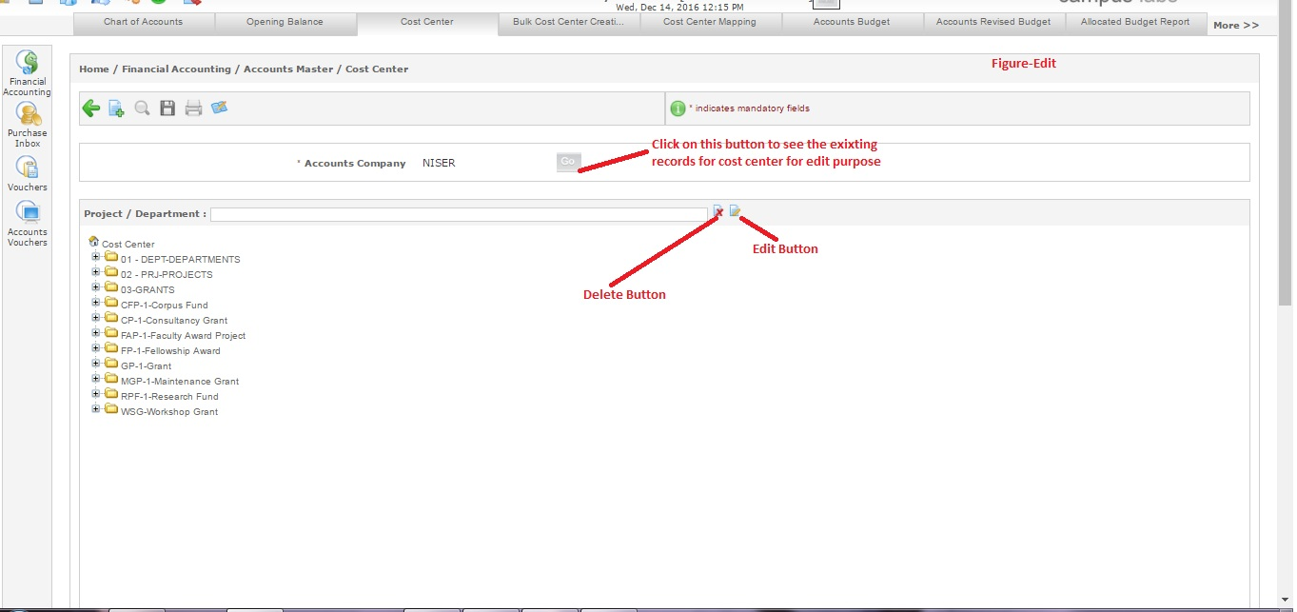
- The form will be opened with the values (that exist currently in associated cost center) for editing.
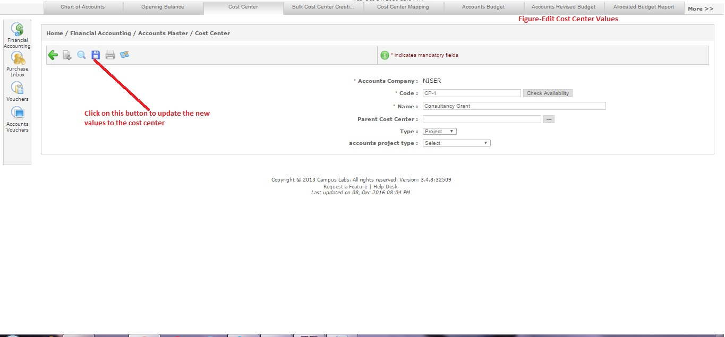
- Update/Change the values.
- Click on “Save” button(Figure-Edit Cost Center Values).
These steps will update the value for record.

Steps to Delete
User can follow these steps to delete any Cost Center:
- Click on “Cost Center” menu from top menu pane.
- Search the record which you want to delete (which you want to delete).
- Select the record which you want to delete by clicking on it.
- Click on delete button associated with the record(Figure-Delete Cost Center).
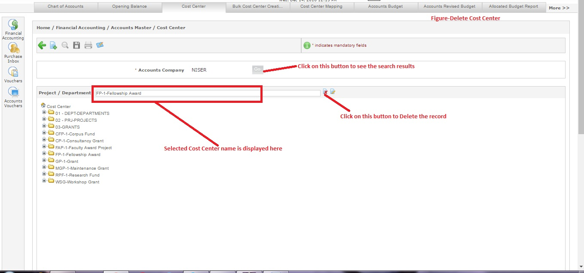
The selected record will be deleted.

Accounts Masters:-
  - Accounts masters details are as follows:
a. Charts Of Accounts:- Accounts admin can categorizes all the things under various charts of accounts(e.g. Assets, Liabilities, Income, Expenses etc.). Admin user can follow these steps to create charts of accounts:
- Click on “Financial Accounting”.
- Select “Accounts Master” option.
- Click on “Charts of Accounts” tab.
- Click on “Add” icon. The form for charts of accounts creation will be opened(Figure-Charts of Accounts).
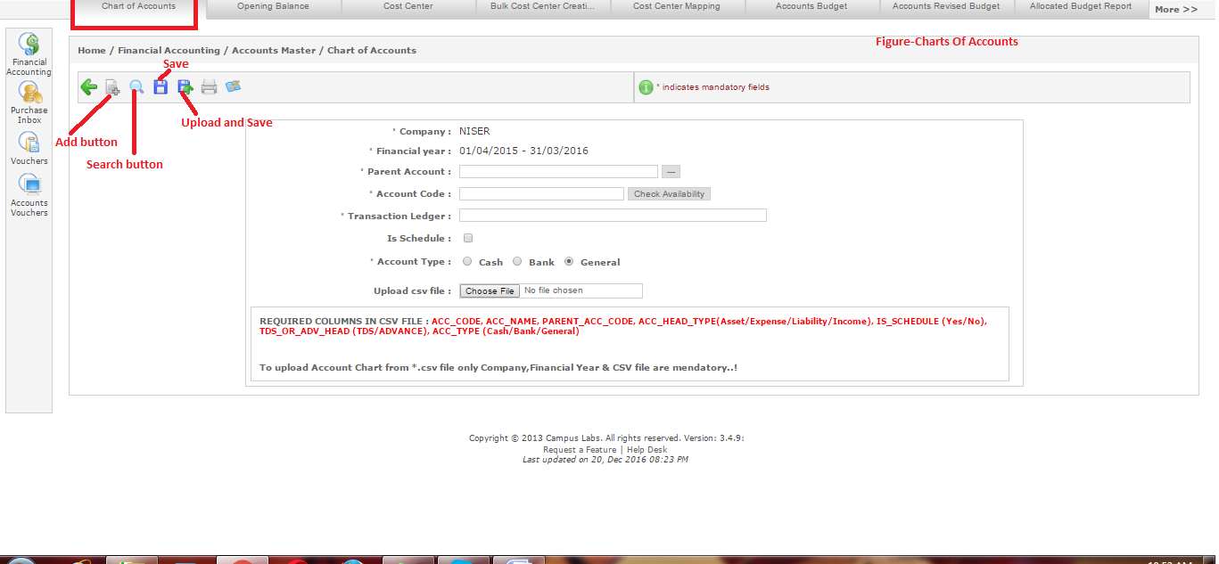
- Enter the details like parent account, account code, account type etc.
- Click on “Save” button if you are not uploading any document. If you are uploading any document through “Upload” option click on “Save and Upload” button.
These steps will create new chart of account.

b. Opening Balance:- Admin can check the opening balances Ledger wise/ Employee wise/ Vendor wise. Admin user can follow these steps to check the opening balance:
- Click on “Opening Balance” tab.
- Select the value for Search filter “opening balance type”.
- Click on “Go” button to see the search results.
- If you want to add new record, Fill the details for Ledger, party and debit values.
- Click on “Add” button(Figure-opening balance).
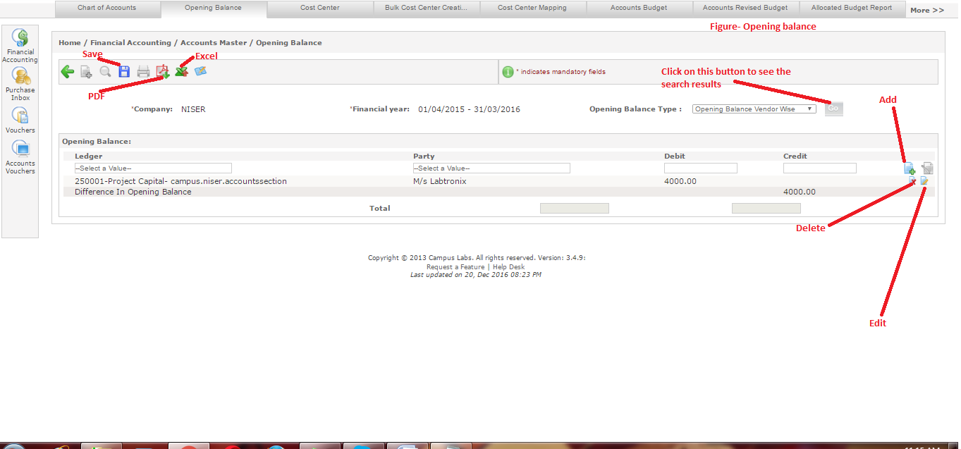
- If you want to Edit the record, click on “Edit” button. Current values will be transferred to relative (party, debit etc.) fields.
- Make updations to the values according to the requirements and click on “edit” button(near add button).
- Click on “Save” button.
- Click on delete button to delete an entry.
c. Cost Center:- Admin user can follow these steps :
- Click on “Cost Center” tab.
- Click on “Add” icon, the form for cost center creation will be opened(Figure-Cost Center).
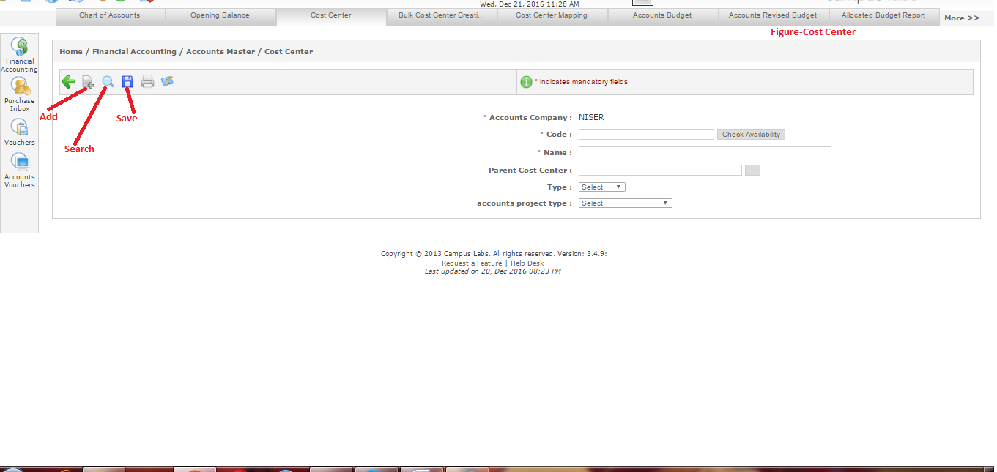
- Enter the details like code, name, parent cost center etc.
- Click on “Save” icon.
- Click on “Search” icon to search existing records.
- Click on “Go” button to see the search results.
- If you want to edit existing record, select it by clicking on it. Selected value will be displayed in the Project/Department field (Figure-Cost center actions).
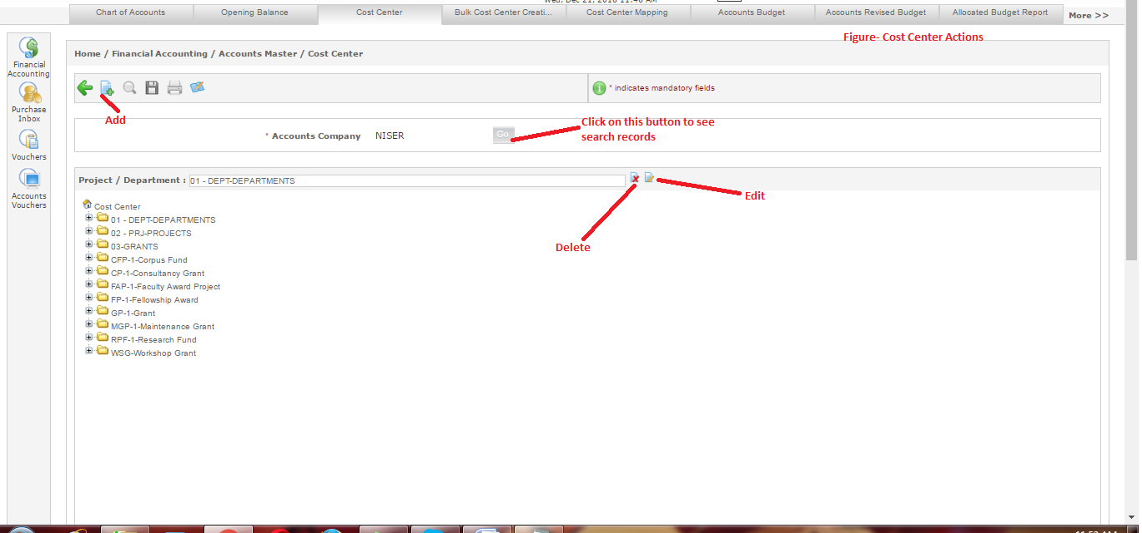
- Click on “Delete” icon to delete the record.
- Click on “Edit” icon to change existing values, the form will be opened with current values.
- Change the values as per requirements.
- Click on “Save” icon.

d. Bulk Cost Center Creation:- Admin user can create bulk cost centers of Department, Projects and Scheme type. Admin user can follow these steps to create the cost centers in bulk:
- Click on “Bulk Cost Center Creation” tab.
- Select the value for Type filter.
- Click on “Go” button to see the search results.
- Select the records for which you want to create cost centers with the help of related checkboxes (Figure-Bulk cost center creation).
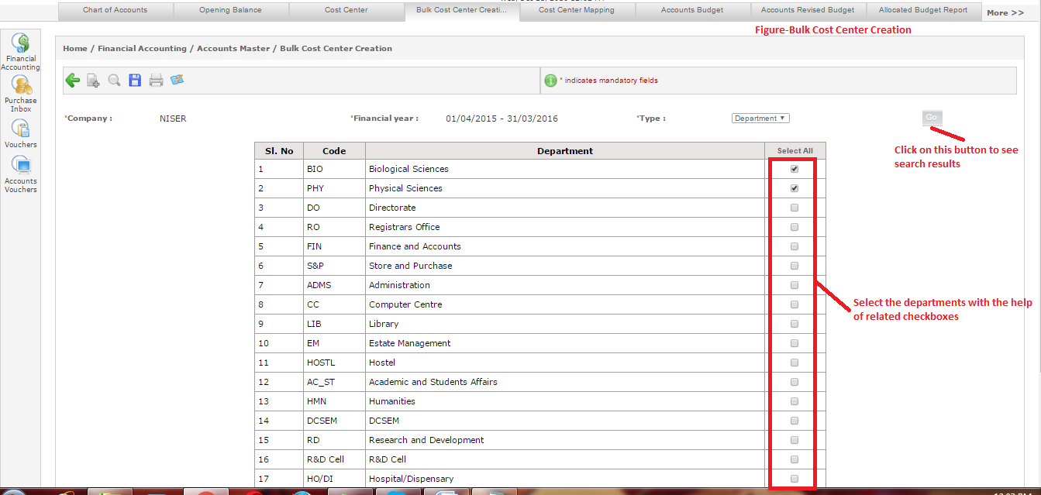
- Click on “Save” icon.

e. Cost Center Mappings:- Admin user can follow these steps to map cost centers:
- Click on “Cost Center Mapping” tab.
- Select the value for Type field.
- Click on “Go” button, the departments and dropdown of cost center will be opened.
- Select the cost center.
- Click on “Save” button to save the mapping (Figure-Cost Center Mapping).
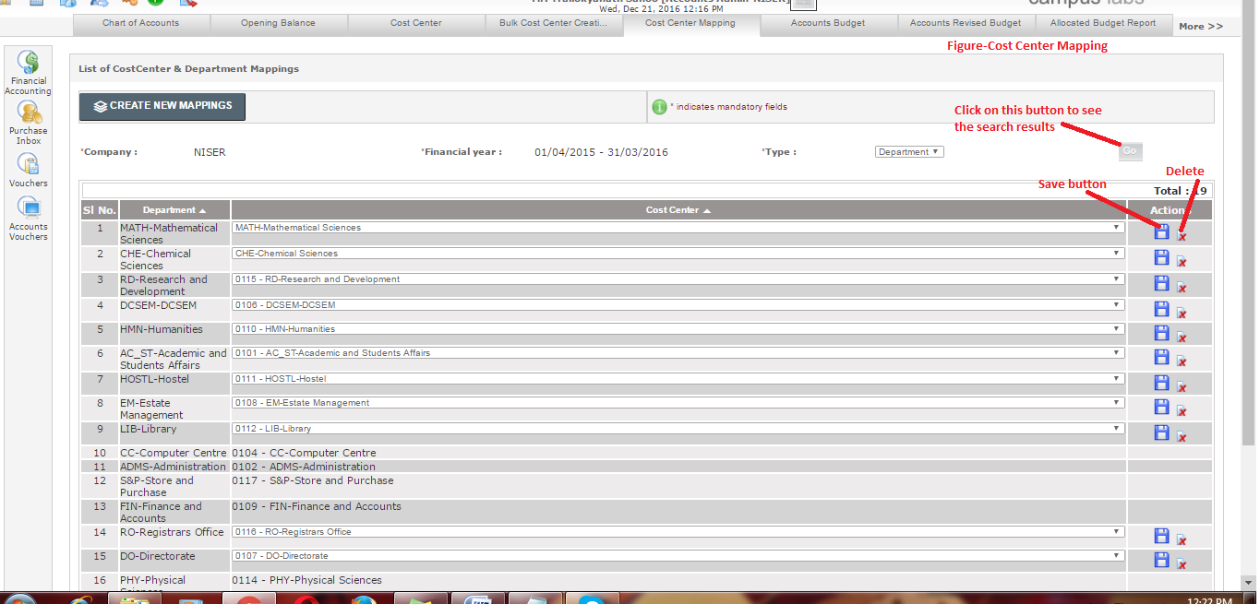
- Click on “Delete” button, if you want to delete the record.

f. Accounts Budget:- Admin user can follow these steps to see the accounts budget:
- Click on “Accounts Budget” tab.
- Select value for “Project/Department” field.
- The accounts budget file related to project/Department will be downloaded.
- If you want to upload budget file, click on “Choose File” button.
- The window will be opened for file selection from the computer, select the file.
- Click on “Upload and Save” icon.
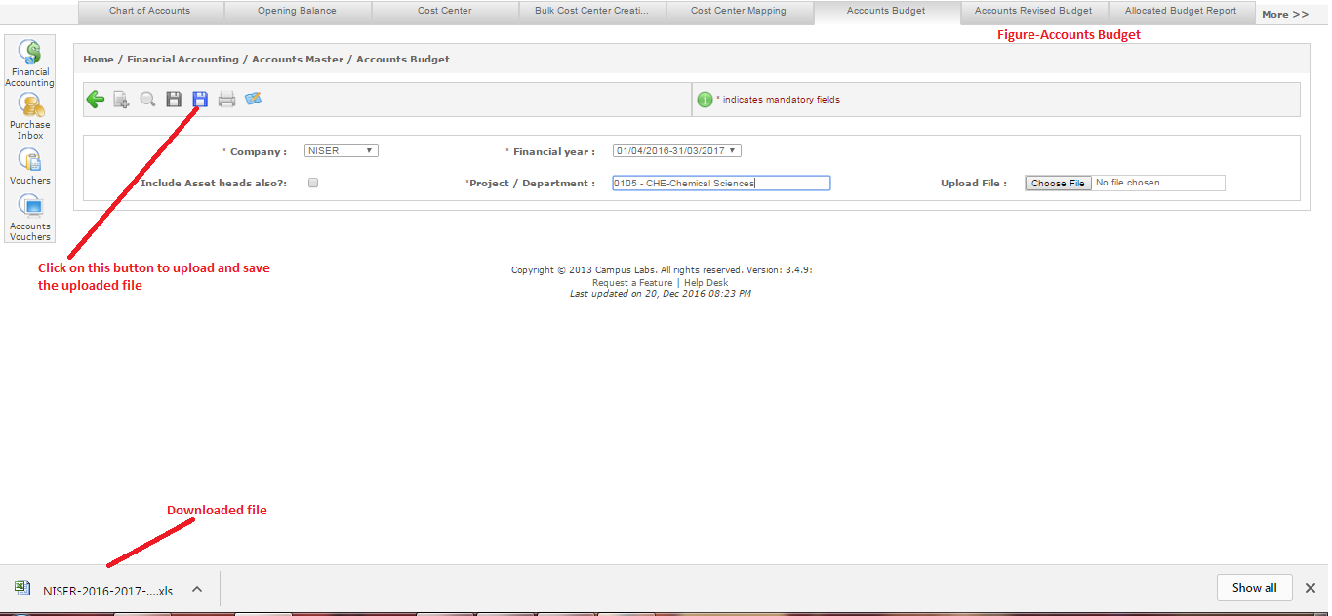
This will upload the selected file (file selected through “upload File” button) for the selected Project/Department.

g. Accounts Revised Budget:- Admin user can follow these steps to see the accounts revised budget:
- Click on “Accounts Revised Budget” tab.
- Select value for “Project/Department” field.
- Click on “Go” button.
- Select the account head to which you want to add revised budget by clicking on it.
- Add the revised budget in “Revised Budget” field (figure-Accounts Revised Budget).
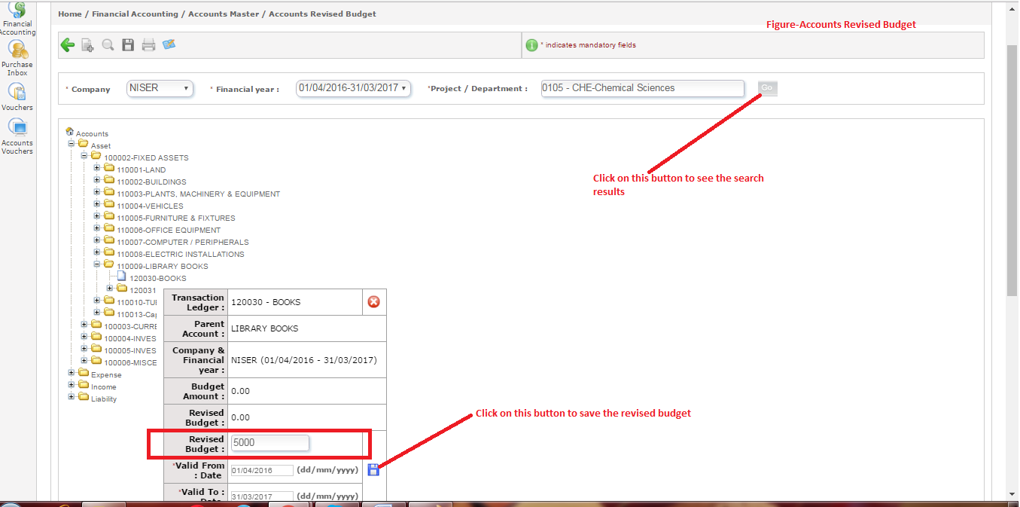
- Click on “Save” icon.

h. Allocated Budget Report:- Admin user can follow these steps to see the allocated budget report:
- Click on “Allocated budget report”.
- Enter the value for search filters.
- Click on “Go” button to see the search results (Figure-Allocated Budget Report).
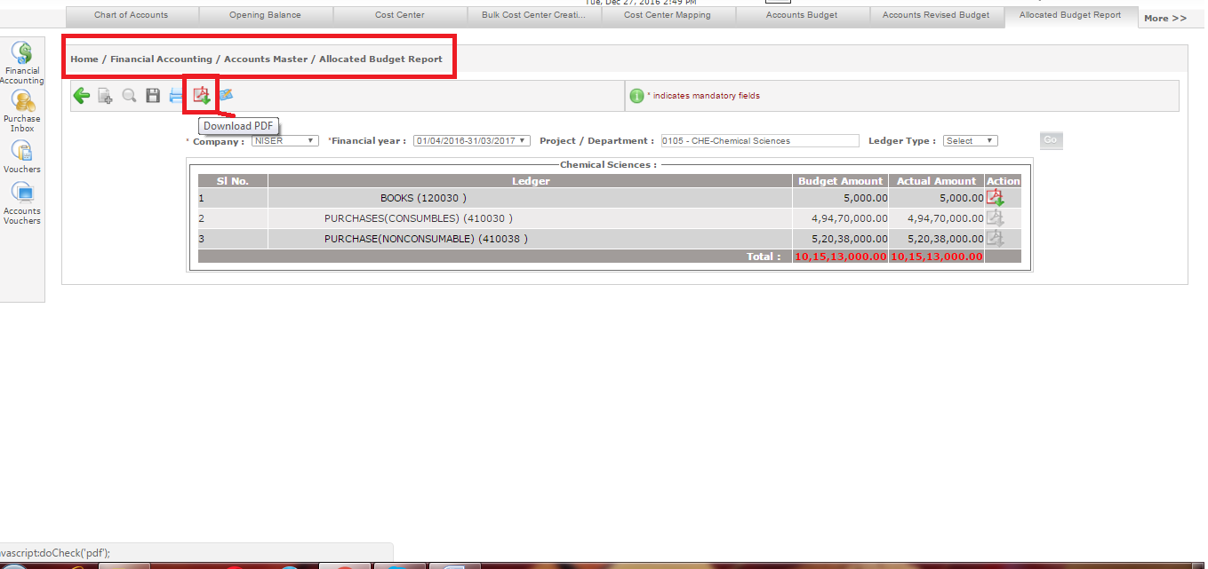

i. Voucher Privilege:- Admin user can follow standard addition, searching and deletion steps for giving voucher privileges to any user id.

Accounts Mapping:-
For classified and summarized financial records accounts user need to do accounts mapping. Through Fee-ledger Mapping user map the fees collected to account ledger. This mapping can be done with two ways:
- Default Mapping
- Fee Pattern Specific Mapping
Default Mapping
User can follow these steps for default mapping:-
- Click on “Financial Accounting” from left menu pane.
- Select “Fee-Ledger mapping” option.
- Select company and financial year.
- Map the credit, bank and debit card.
- Click on save button (shown in figure below).
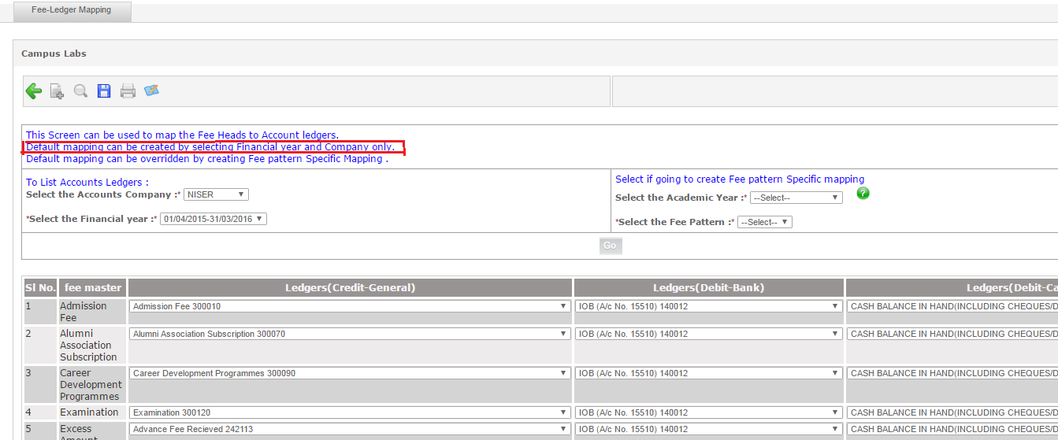

Default Mapping
User can follow these steps for fee pattern specific mapping:-
- Click on “Financial Accounting” from left menu pane.
- Select “Fee-Ledger Mapping” option.
- Select Accounts company, Financial year, Academic year and fee pattern.
- Map the ledgers according to fee heads by selecting ledger from the dropdown provided.
- Click on save (shown in figure below).
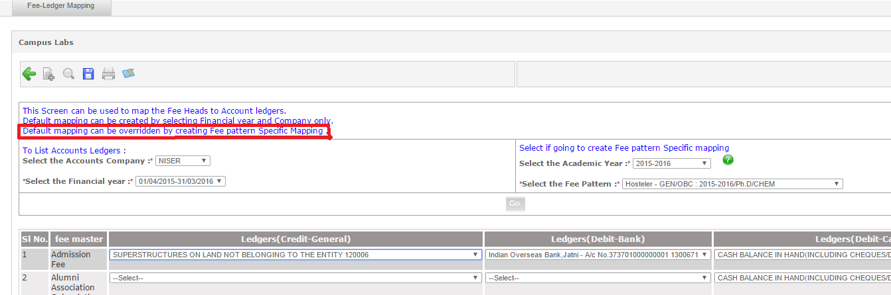

Accounts Transactions:-
  - Accounts user can perform several transactions such as voucher entry, bulk payment, book entry etc. which are shown in figure-2.
For addition, search, updation and deletion perform the Standard steps.

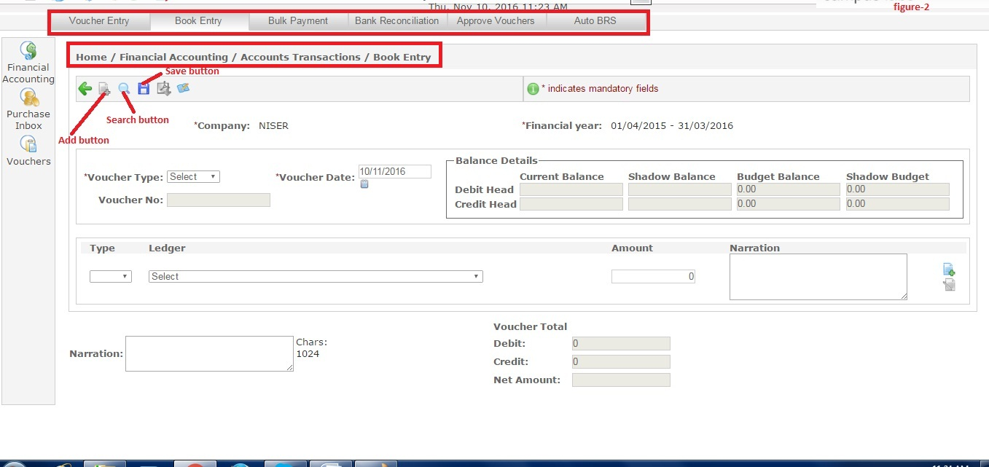

Vouchers:-
  - Accounts admin needs several types of vouchers depending on the requirements. With the help of this module the Admin user can see the several types of vouchers such as contra voucher, receipt voucher, payment voucher etc. and also can take printout of the voucher and can download the voucher in PDF format (Figure-3).
To see a voucher details follow the standard steps for search.
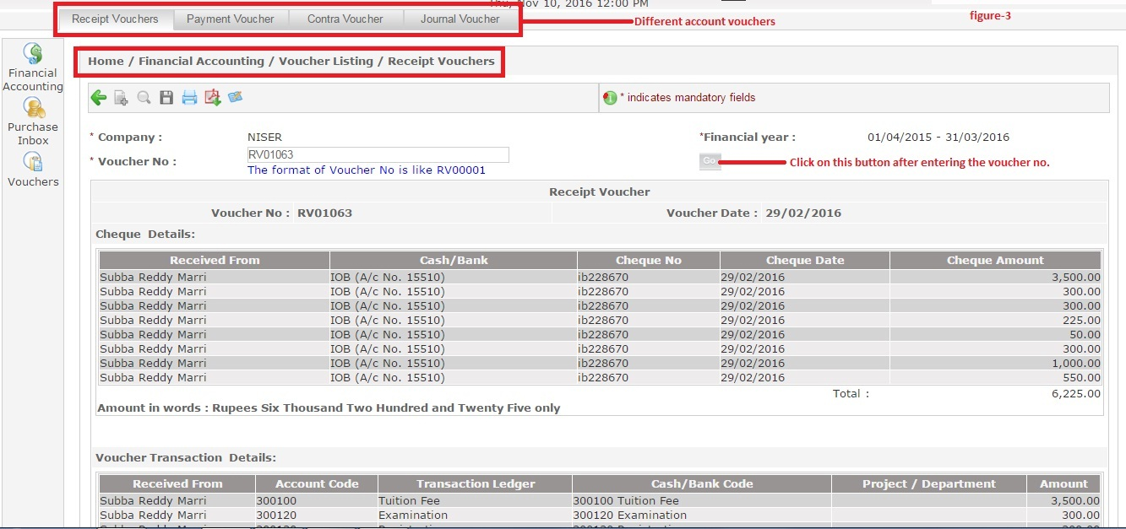

Financial Reports:-
  - Campuslabs system provides several financial reports which the Accounts admin user can use according to his/her requirements (figure-4).
To get the report from the system you need to click on the relevant tab and follow standard search steps. For example Day book report is displayed in figure-4.
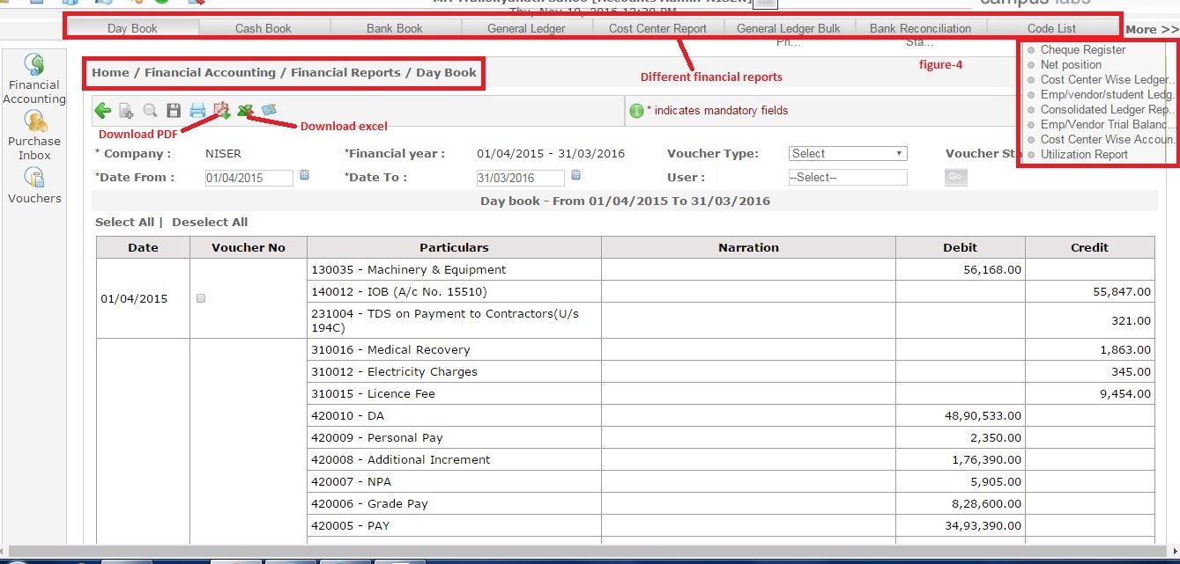

Financial Statements:-
  - Campuslabs system has provided different statements related to accounts for different accounts related purposes which are shown in figure-5.
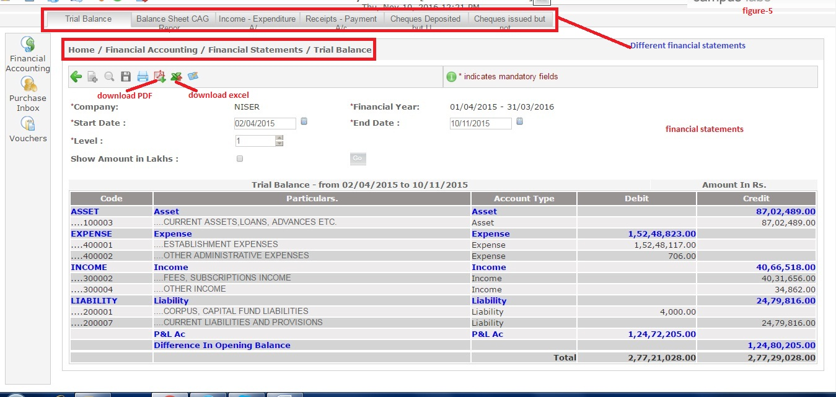
To get the statement go to the related tab and follow standard steps for search.
The accounts admin user is facilitated with pdf and excel downloads of the statement. For download of report click on the Download pdf or download excel button as per your requirements.

