HSS 102
March 21, 2015

The Copernican Revolution
In the year 1543, two books were published which changed the course of science and started the scientific revolution. These books are:
Nicolaus Copernicus’s De Revolutionibus Orbiusm Coelestium ( Or the Revolutions of Celestial Spheres)

Andreas Vesalius’s De Humani Corporis Fabrica (the Fabric of the Human Body)
In this lecture we will look at the revolution in astronomy that Copernicus began.
COPERNICAN REVOLUTION was one of the most momentous events in the making of the modern worldview. There are two broad meaning associated with the term “Copernican Revolution”:
- In physics, it refers to the revolution in astronomy initiated by Copernicus. Copernicus’s ideas started a complex and a prolonged affair, more like a relay race in which the torch of new ideas was passed. It started with the publication of Copernicus’s The Revolution of the Celestial Spheres (De revolutionibus orbium coelestium) in 1543, and culminated with the publication of Sir Isaac Newton’s Philosophia Naturalis Principia Mathematica in 1687. In between the inception and the completion stood two of the most intriguing and creative scientists, namely Johannes Kepler and Galileo Galilei (1564-1642).
- As a metaphor for any radical change in ideas. For e.g., Freud’s explanation of hysteria as a result of un-conscious impulses has been described as a “Copernican revolution” in psychology; Kant described his contribution as “Copernican Revolution” in philosophy.
Momentous changes
- EARTH IS TURNED INTO A PLANET, a wanderer – an idea that was unthinkable in Aristotelian and Ptolemaic astronomy: against the nature, the very essence of the fundamental elements… after all, earth was in the center of the universe because it was the essence of earth to fall to the center.
And yet, Copernicus set afloat the earth in space, rotating along its axis and rotating around the sun.
It is no longer the center of the universe, but merely one of the planets orbiting the sun
- This will gradually prepare the way for the Newtonian Revolution.

COPERNICUS as an ACCIDENTAL REVOLUTIONARY:
Copernicus displaced the earth from the center of the universe and put the sun in its place. But he did this not to overturn Ptolemy’s model, but only to “improve” it, by making it more Aristotelian.
He attacked Ptolemaic astronomy not because it is earth-centered, but because it does not adhere to the dogma of uniform circular motion. Ptolemy had kept the circular dogma, but not uniform dogma: a planet could move at a non-uniform speed from the center as long as it was made to appear to move at a uniform speed around a point called equant.
Copernicus thought the equant was illegitimate violation of Aristotle and Plato, and sought to restore the purity of the uniform circular motion dogma.
Copernicus saw his major contribution as elimination of the equant, and not the dethroning of the earth.
SO Copernican revolution was a revolution only in the sense of a return to the ideal past, a ritual of purification in which all innovations will be eliminated; not a revolution in the sense of a radical break from the past.
Let us look closer at Copernicus’s story.

Who was Copernicus?
His complete name was Nicolas Copernicus. (Copernicus is a Latin form of the Polish name, Koppernigk). He was born in 1473, half way between invention of the printing press and the discovery of the New World in 1492. He was born in a town called Torun in what is now N-W Poland. His family was well to do, his father being in the copper trade.
He was educated in universities of Cracow, Bologna, Padua and spent a year in Rome (the year was 1500) where he gave occasional lectures on astronomy. It is in his year in Italy that his interest in the heliocentric (i.e., sun-centered) universe began to take place.
By this time, printing presses had been established. And he had access a copy of The Epitome of the Almagest, a very popular summary of Ptolemy’s work written by a German ( Johann Muller) in 1461.
It looks like that right from the beginning, Copernicus was troubled by the inelegance and complicated machinery of Ptolemaic astronomy – he compared it to a “monster”. So for the next 10-15 years studying the Almagest and making his own observations. We have records of his observations of lunar eclipses and conjunction of Saturn and the moon. He lectured on mathematics and astronomy in Rome and taught himself Greek and kept on watching the skies.
Thanks to the connections with an influential uncles, N.C. had been given the position of a Canon (administrator) of Frauenburg Cathederal. He joined his duties at this cathedral when he was 40 and lived there his whole life. He died in the tower that he lived in .

The Commentariolous
The first intimation of the Copernican system was contained in a short treatise with NC wrote sometime between 1510-1514. It was called the Commentariolous (the Commentary), it was never printed but circulated as a hand-written manuscript and bore the subtitle:
A brief outline of Nicolai Copernicus’
Hypothesis on the heavenly motions.

He begins by exlpaining that Ptolemy’s system was unastifcatory because it did not fulfill the basic depamnd of the ancients that the each planet should move with uniform speed in perfect circle. Ptolemy’s planets move in cirlces but not with uniform velocity: they only appear to move at uniform velocity with respect to the equant point.
[Here Copernicus was not being terribly original. Islamic astronmoers had been critical of Ptolemy precisely on this issue of equant. There had been at least 14 critical commentaries written by Islamic scholars on this issue. Copernicus mentions at least five Islamic authors by name. Copernicus will also employ the Tusi couple, a mathematical device first proposed by the 13th-century Persian astronomer and mathematician Nasir al-Din al-Tusi in his 1247 Tahrir al-Majisti (Commentary on the Almagest) as a substitute for the equant.
This is not acceptable to Copernicus. So he wanted to create a system that got rid of the equants and made the planets actually move at a unifrom speed around a central point. He wrote:
“Having become aware of these defects (ie., equant), I often considered whether there perhaps be found a more reasonable arrangement of circles in which everything would move uniformly around its proper center, as the rule of absolute motion requires.”
He said he could produce such a model, provided he was allowed to entertain seven axioms, or assumptions. Below are five of the seven assumptions he made (the numbers are the numbers on the list of seven by NC.
#2 That the earth is not the center of the universe, only at the moon’s orbit and the center of gravity toward which bodies on Earth are attracted.
#3. All the heavenly bodies, except the moon revolve about the Sun, which is therefore the center of the universe.
#5. The apparent daily revolution of the stars around the earth arises entirely from the Earth’s rotation around its axis.
#6. The apparent annual motion of the sun arises jointly from the rotation of the Earth on its axis and the Earth’s revolution (like that of the other planets) around the sun.
#7: the apparent retorgrade motion of the planets arises from the Earth’s motion, occuring when the Earth passes Mars, Jupite or Saturn, or is passed in its orbit by Mercury or Venus.
In the rest of the Commentariolous, he goes on to describe the new model, the new cirlces and epicylces of the sun, the moon the planets. He does not offer any matmematical proof, saving that he is reserving the proofs for his “larger work” (which will be the famous The Revoltuion that came out in 1543. )
He wrote the mansucript of his larger work – the Revolution of Celestial Spheres– but kept it locked up in his desk for many years before it was finally printed in 1543 when C was dying.

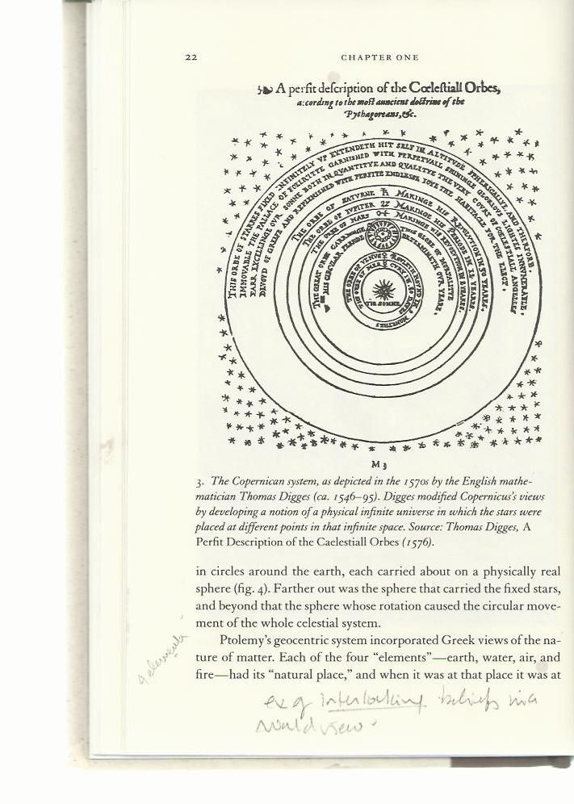

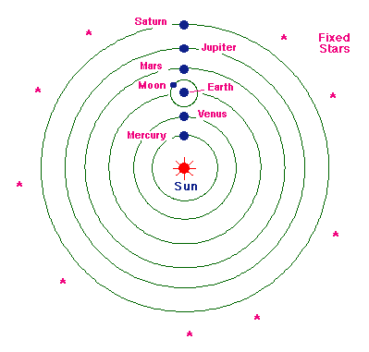

A modern rendering of Copernicus’s system in its basic outline.
What were the main features?
- There are no equant points.
- But NC keeps the epicycles. Even though he does not need epicycles any longer to explain the apparent retrogression (zig zag) of the planets, he still keeps them as useful mathematic computing devices for making predictions about planetary positions.
- NC writes: “Mercury runs of seven circles (i.e. epicycles), Venus on five, the earth on three, around it the moon on four, finally, Mars, Jupiter and Saturn on five each. Altogether, therefore, 34 circles suffice to explain the entire structure of the universe and the entire ballet of the planets.”
- Provides a natural explanation for the retrogression of planets. Using the example of Mars (which applies to all other planets as well), the earth is the third planet from the sun, while Mars is the fourth planet and has a larger orbit. Every two years or so, the earth catches up with Mars and passes it. When that happens, it looks from the earth that mars is moving backwards. Thus, in C’s system, planet’s retrogression had a simpler explanation that did not require the use of epicycles. This was a big advantage of the system that his supporters often cited.

The Reception of the Copernican model:
Contrary to the common misconception, the Catholic Church did not oppose the model Copernicus offered in the Commentariolous. His final book, the Revolutions, was put on the index of prohibited books during the controversy over Galileo, some 73 years after it was published.
Copernicus actually was living in the golden age of intellectual tolerance, and the pope at that time, Leo X was/is highly respected for creating a culture of openness, debate and bold ideas. Scholars and philosophers had no reason to fear persecution as long as they refrained from a DIRECT assault on the Church.
Because of its radical propositions, NC’s manuscript was circulated quite widely. It was read by the church scholars who considered him to be a highly regarded astronomer and invited him in 1514 to a conference on revision of the calendar.

Ten year later, the personal secretary of the pope Leo X gave lectures on Copernican system. Another cardinal of the Pope, urged NC “to communicate your discoveries to the learned world” by printing the final book.

NC then sat down and wrote his more elaborate Revolution, but refused to get it printed.
Protestant opposition:
"There is talk of a new astrologer who wants to prove that the earth moves and goes around instead of the sky, the sun, the moon, just as if somebody were moving in a carriage or ship might hold that he was sitting still and at rest while the earth and the trees walked and moved. But that is how things are nowadays: when a man wishes to be clever he must needs invent something special, and the way he does it must needs be the best! The fool wants to turn the whole art of astronomy upside-down. However, as Holy Scripture tells us, so did Joshua bid the sun to stand still and not the earth."
The scriptural passage to which Luther refers is Joshua 10:10-15. Elsewhere Luther refers to Copernicus as "a fool who went against Holy Writ". It is this latter quote that usually makes it into the textbooks.
At another place the Bible says “The Sun also rises and the Sun goes down, and hastens to its place where he rose.” (Ecclestiastes, 1:5).

Historians have long puzzled over why NC was so reluctant to publish his great work. There was no threat of religious persecution. So why?? Looks like he was a timid man by nature and did not want to create any kind of stir. It is also conjectured that he was influenced by the Pythagorean tradition and believed that only a small select group of true knowers should be included in matters of such importance. Getting Copernicus to agree to publish it makes a very interesting story in itself. So let us look at this story

The arrival of Rheticus
In 1539, a young prodigy in mathematics and astronomy, someone by the name of Georg Joachim van Lauchen (who went by the name of Rheticus, because he was born in that part of Austria which used to be called Rhateia) came to visit Copernicus. Rheticus was to play a crucial role in getting Copernicus to publish his major work.
Rheticus (b. 1514) was a brilliant scholar who, at the age of 22, had become a full professor of mathematics and astronomy at the University of Wittenberg. Wittenberg was the home of Martin Luther who had started the Protestant revolt against the Roman Catholic church. Martin Luther himself had spoken against Copernicus’ system. So it is quite remarkable that the highly Protestant university of Wittenberg gave Rheticus a long leave to come and learn from Copernicus.
R was 25 years old and NC was 66 years old when the two met in NC’s tower.
Rheticus, along with another friend of Copernicus, do their best to convince Copernicus to publish the Revolutions. Copernicus does not agree, but reaches a compromise: He would allow Rheticus to read the manuscript and publish a summary under his own name.
So Rheticus got down to work. He spent about 10 weeks studying the manuscript in real earnest and by September 1539 he had succeeded in distilling its major findings in a book he called the Narratio Prima (the First Account) was soon published. In the intro to the book, Rheticus assures his readers that “my teacher” (i.e. Copernicus) “fully believed that for him there was nothing better than to walk in the footsteps of Ptolemy, and to follow… the ancients.” He was “compelled to make assumptions” that challenged Ptolemy only because of the phenomena that he was trying to explain etc. He prophesized that “the astronomy of my Teacher may rightly be called Eternal, as the observations of the past ages testify and the observations of the prosperity will doubtless confirm…”

Copernicus’s Revolutions is finally published

After the Narratio is printed, NC finally relents and agrees to have his book printed. (Maybe he was using Rheticus’s Nararaio Prima as a trial balloon to see what kind of reception his book will get.)
So Rheticus through most of 1540 and 1541, Rheticus copied the 424 pages long manuscript in his own hand, checking the figures and making corrections.
Then he took it to the printers in the town of Nurenberg.
But in the middle of the printing, Rheticus, who had worked so hard on the project, loses all interest and returns promptly to his teaching job in Wittenberg. Why?? The historians believe it is because Copernicus had totally excluded any mention of him from the acknowledgements he wrote for the book. Rheticus had devoted his life to Copernicus and it is easy to understand that he would be deeply hurt by this neglect.
So he left the printing in the care of Andreas Osiander, who was a well known theologian-intellectual and who was one of the founders of Lutheranism (a Protestant Christian sect).
Osiander wrote an anonymous reface to the Revolutions and inserted it in the book. The preface was addressed TO THE READER, CONCERNING THE HYPOTHESES OF THIS WORK”. The preface basically advised the readers not to take the hypotheses too seriously (!!): “For these hypotheses need not be true, or even probable” and it was sufficient that they should “save the appearances” i.e, account for the observed motions of stars. He was basically urging the readers to read this book not as literally true, but only as a device for practical calculations, for “saving the appearances” or as Osiander had explained to Copernicus “not as article of faith, but bases for computation.”
Historians dispute whether Copernicus knew of this preface and did he approve of it?? The best evidence taken from Rheticus’ writings suggests that a copy of the preface WAS sent to C and he was “more than a little irritated by it.” so it looks like that NC knew of Osiander’s preface. He was probably too ill by that time to do anything about it. He himself believed that his model was describing the real motion of the earth and the planet and was NOT just a device for computation.

Some questions about what inspired Copernicus:

The question arises: what inspired Copernicus to bring the Sun in the center? (see #3). According to Arthur Koesteler in The Sleepwalkers, Copernicus was familiar with the ideas of ancient Pythagoreans – especially Philolaus and Herakleides – who had proposed that the earth and the rest of the planets move around an invisible fire (see earlier lecture on astronomy). In fact, in the dedication of his book to the Pope, Copernicus states clearly that he was inspired to give motion to the earth when he read that the students of Pythagoras (Philolaus and Haraklides) had done that. Here is the relevant passage from the dedication: Please see the pdf of Copernicus dedication to the Pople that I have attached.

The Book of the Revolutions of the Heavenly Spheres
Has been decribed as the “all time worst seller.” The first edition numbered a thousand copies, which never sold out. Apparently, the book was “supremely unreadable” (to use Arthur Koestler’s words).
Today, everyone cites Copernicus as the astronomer who showed that the sun was in the center and that the planets moved around it. But his model was not so neat and clear. Copernicus made radical claims in both the Commentariolus and the Revolution, but when it came to actually describing and explaining his claims, he would actually dilute the radicalness of his claims. Consider the following:
- NC claimed (Book 1, ch. 10, of the Revolutions): “ in the middle of all dwells the sun…sitting on the royal throne, he rules the family of planets which turn around him.”

But when it came to reconciling this statement with the actual data, he described the earth NOT as turning around the sun, but around a point in the space removed from the sun by a distance of about 3X the sun’s diameter!

- The planets move not around the sun in perfect circles, as he claimed, but on epiccyles of epicycles, centered NOT on the sun, but on the center of the earth’s orbit. As A. Koestler puts it, “ there are thus two “royal thrones”: the sun and the imaginary point in space around which the earth moves.
- Far from being simpler, Copernican model in the Revolutions had actually MORE epicycles – 50 of them – as compared to Ptolemy who had “only” 40! (there were 34 epicycles in Copernicus’s Commentarolis. He had added more by the time he wrote the Revolutions.)

So the question arises, why Copernicus succeeded in winning so many followers? Why would such a book as Revolutions which was difficult to read and offered no great clarity succeed in bringing about the Copernican Revolution??
The principal advantage of the Copernican system was its greater geometrical simplicity in one essential aspect: it could explain the retrograde motion of the planets which had so worried the ancients. By transferring the hub of the universe from the earth to the sun, the Copernican model could provide a NATURAL reason for the planets’ behavior: if the hub was the Sun or near the sun, and the earth turned around it together with other planets, it was obvious that each time the earth “overtakes” the outer planets (which circle at a slower rate), that particular planet will appear to recede for a while, and each time the earth is overtaken by a faster moving inner planet, that planet will appear to reverse its direction.
This was an enormous gain in elegance and simplicity.

Copernicus’s Aristotelian arguments in support of Earth’s motion
In contrast to the preface by Osiander, Copernicus asserts many times in the book that the earth REALLY moved.
But at that time, there were many perfect sensible objections –based upon everyday, commonsense observations -- to the idea that earth really moves. People used to worry that falling bodies will be left behind by the moving earth, the earth itself will fly off, the atmosphere will be left behind etc.
Copernicus answered these objections with a rather old-fashioned perfectly Aristotelian argument. He said that earth is a sphere and that it is the “essential nature” of all spheres to turn. Since rotation is the “natural motion” of the earth, it cannot have such violent effects (i.e. the earth and the air flying off etc.) because natural motions cannot “by nature” have violent effects !!
So he carried the orthodoxy regarding circles and spheres and their essential nature even furhter than Aristotle and Ptolemy.
This is why Copernicus is often called the “Last of the Aristotelians” rather than the First of the Moderns, even though he gave birth to the idea that would usher in the modern world.

